DOSSIER
Date (dd/mm/yyyy) : 21/03/2014 |  | Call ID: 483
URF: Please Attach URF file, received from ODO
ECO on-duty
Name | Seiki Matsuoka
Agency | JAXA
Phone | +81-90-3687-9171
Fax | +81-49-298-1001
Mail | z-charter_eco@eoc.jaxa.jp
AU
Name / Organization | Brazilian Disaster and RISC Management National Centre (CENAD)
Address | Ministério da Integração Nacional Secretaria Nacional de Defesa Civil  Esplanada dos Ministérios - Bloco "E" 7º andar - sala 766  70067-901 Brasília, DF – Brasil
Phone | +55 61 3214-0600 / Celluar +55 61 9694-7647
Fax | +55 61 3214-0600
Mail | Marcus.santos@integracao.gov.br
EU
Name / Organization | Brazilian Disaster and RISC Management National Centre (CENAD)
Address | Ministério da Integração Nacional Secretaria Nacional de Defesa Civil  Esplanada dos Ministérios - Bloco "E" 7º andar - sala 766  70067-901 Brasília, DF – Brasil
Phone | +55 61 3214-0600 / Celluar +55 61 9694-7647
Fax | +55 61 3214-0600
Mail | Marcus.santos@integracao.gov.br
Emergency type
Earthquake Flood Ice Storm / Hurricane
Fires Industrial danger Landslide Volcano
Other:

Area details
Area Name / Country | North Region of Brazil
Map of interest:

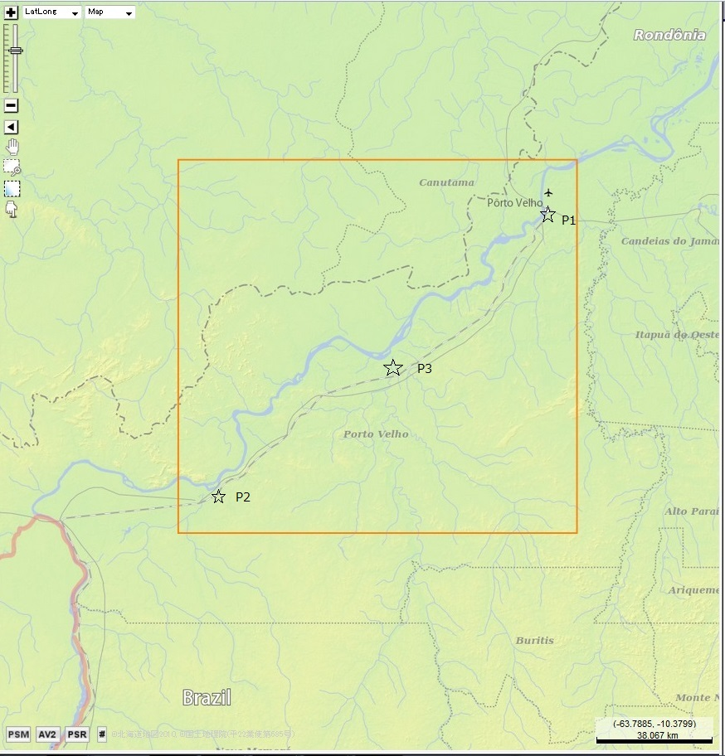
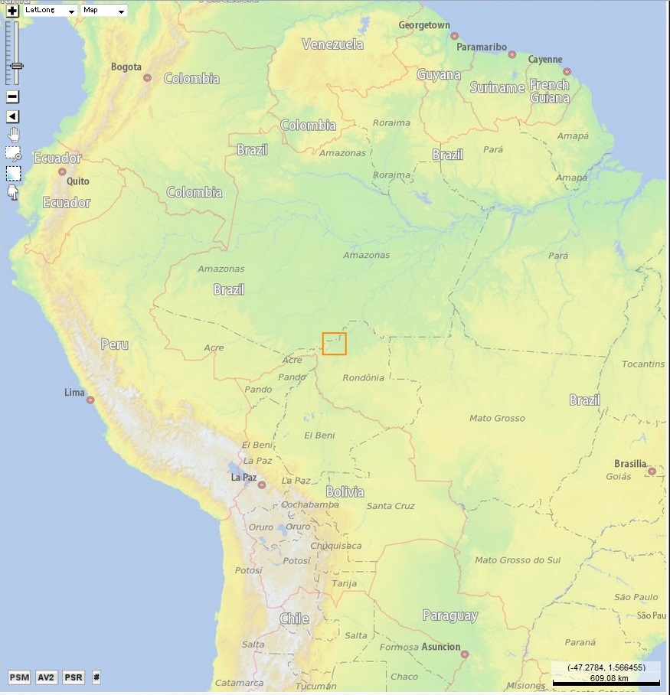
General Information on the event:

The Madeira River, which runs through Porto Velho, Rondônia in western Brazil, has reached a record water level of 18.73 meters and is still climbing today. The flooding has almost completely isolated the area in the upper Amazon River basin, as the BR-364 highway, the only land-link with the rest of the country, had to be closed on Monday and very few vehicles are able to make their way through the rising water.

More than 2,000 families are currently affected by the flooding and 43 shelters in Porto Velho and other districts have been opened to those in need. In the areas of San Carlos and Nazareth, all residents had to evacuate their homes. The National Secretariat for Civil Protection and Defense sent 500 tents with ten person capacities to Rondônia, which will be installed in the middle and lower Madeira region, according to Colonel Farias.

http://riotimesonline.com/brazil-news/rio-politics/national-politics/flooding-in-amazon-basin-isolates-rondonia-state/?utm_source=feedburner&utm_medium=feed&utm_campaign=Feed%3A+TheRioTimes+%28The+Rio+Times%29#
Information and preferences provided by Requester:
It is occurring a gradual flooding, which started on February 15th, 2014, reaching its highest level on March 19th, 2014.

The cities located at lower part of Amazon River basin, more specifically located at the river Madeira basin, are being affected by a gradual flooding, which started on February 2014. The rivers levels are increasing day after day, and the water has already covered many residential and production areas in these cities, and also has covered some parts of BR-364, highway that is the main access by land from Porto Velho to Rio Branco, capitals of Rondonia and Acre States respectively.

Acquisition & Archives Plan
Agency | Satellites | Program / Archive
CNES  ESA  CSA  ISRO  ISRO  CONAE  NOAA  USGS  DMCii  JAXA  CNSA & INPE  CNSA  DLR  KARI  ROSCOSMOS  ROSCOSMOS | PLEIADES SPOT5 SPOT4*  ENVISAT* ERS2*  RADARSAT  IRS-P5 Resourcesat-2 Oceansat-2  IRSP6 * Cartosat-2 Risat-2 IMS-1  SAC-C*  POES GOES  LANDSAT VHR Commercial  DMC MRI DMC VHRI  ALOS* KIBO HDTV-EF  CBERS*  SJ-9A  TerraSAR-X/TanDEM-X  KOMPSAT-2  Meteor-M Kanopus-V Resurs-P  Resurs-DK* | Pr. Ar.  Pr. Ar.  Pr. Ar.  Pr. Ar.  Pr. Ar.  Pr. Ar.  Pr. Ar.  Pr. Ar.  Pr. Ar.  Pr. Ar.  Pr. Ar.  Pr. Ar.  Pr. Ar.  Pr. Ar.  Pr. Ar.  Pr. Ar.
ERF:
Please attach all the ERF files sent as well as an event log prepared by the ECO along with a summary of any difficulties encountered

*Only archive images are available
EUMETSAT data of Meteosat and Metop satellites do not need to be tasked by ECO. For relevant scenarios EUMETSAT will provide imagery to the PM in support of a Call. PMs may request additional data from EUMETSAT as needed.
EMERGENCY REQUEST FORM FOR PLEIADES DATA (specific part)
International Charter on Space and Major Disasters
Requested image location details (KMZ and SHAPE files are also accepted)
Area Name / Country :
KMZ or Shape file attached
Surface of the AOI must cover a minimum
of 100 square/km to a maximum of 400 square/km
(agreement to be confirmed by CNES in case of larger areas).
Coordinates of image center point for the highest priority area (ONLY in Degrees, Minutes, seconds)
(Or Upper Left and Low Right coordinates)

Latitude : .... ° .... ’ ...” N / S
Size (lenght * width km)
Longitude : .... ° .... ’ ...” E / W
Size : ...... (between 10*10km and 20*20 km)

Coordinates of image center point for another area (agreement to be confirmed by CNES)
(Or Upper Left and Low Right coordinates)

Latitude : .... ° .... ’ ....” N / S
Longitude : .... ° .... ’ ....” E / W
Size : ...... (between 10*10km and 20*20 km)

New acquisition request (*):
First acquisition date : . . / . . / . . . . (dd/mm/yy)  or As soon as possible |  |  |  |  | N.B. : the programming on this area  will be activated for one week nominally
Requested image(s) : 0.5m Panchromatic 0.5m Multispectral 2m Multispectral

 | Pre-processing level : |  | Primary : radiometric corrections, at system level  Ortho (SRTM standard)
Archive data request (*):
archive search requested OR image ID ( Pléiades image ID)……………………………..
To be selected in https://geostore.astrium-geo.com/common/
Pre-processing level : |  | primary or ortho (SRTM standard)
Additional information / instructions :

(*) CAUTION : a maximum of 2 images in total (for example one archive plus one new acquisition) shall be ordered by the ECO, on the same area (If more images or extension of the target area, or extension of the programming period are needed, an agreement must be requested to CNES (charte.risques@cnes.fr) with copy to ASTRIUM GEO Information (charter.disasters@spotimage.fr).

EMERGENCY REQUEST FORM FOR SPOT DATA (specific part)
International Charter on Space and Major Disasters
Requested image location details: ONLY center point can be accepted
Area Name / Country :  North Region Porto Velho  / Brazil |  | Coordinates of image center point for the highest priority area : (ONLY in Degrees, Minutes, seconds)  Latitude : ...8° ..46 ’ .13” S  60*60 km  Longitude : ...63° ..54 ’ .21” W  Coordinates of image center point for another area (agreement to be confirmed by CNES)  Latitude : .... ° .... ’ ...” N / S  Longitude : .... ° .... ’ ...” E / W
New acquisition request (*):
First acquisition date : . . / . . / . . . . (dd/mm/yy)  or X As soon as possible |  |  |  |  |  |  | N.B. : the programming on this area  will be activated for one week nominally
Requested image(s) :
10m  X 5m -2.5m |  |  |  |  |  | X Panchro (Black and White)  X Multispectral (Colour)
 | Pre-processing level : |  |  | 1A : radiometric corrections, at system level  1B : radiometric and geometric corrections, at system level  2A : images are rectified to match a standard map projection (UTM WGS  84), using a global DEM but without using ground control points
Archive data request (*):
X archive search requested OR image ID ( SPOT image ID)……………………………..
To be selected in https://geostore.astrium-geo.com/common/
Pre-processing level : |  |  | 1A or 1B or 2A
Additional information / instructions :
SPOT5 Acquisition : covering Center Point n°1 defined in ERF common part
- Archive :
- Most recent archive available with same season
- ensuring that the archive scene does not show a previous flood event
- multispectral and panchromatic data, delivered separately.
(*) CAUTION: a maximum of 2 images in total (for example one archive plus one new acquisition) shall be ordered by the ECO, on the same area (If more images or extension of the target area, or extension of the programming period are needed, an agreement must be requested to CNES (charte.risques@cnes.fr) with copy to ASTRIUM GEO Information (charter.disasters@spotimage.fr).

1. Guidelines for Indian Remote sensing Satellite (IRS) Data request
Indian Space Research Organisation (ISRO)/ National Remote Sensing Centre (NRSC)
International Charter on Space and Major Disasters

Requirements for IRS Data ordering:

- Desktop PC, running on Windows
- Email/Internet
- IRS Data request form
- New data acquisition planning for IRS will be done by NRSC based on the ECO request.
- The user’s needs to establish access to NRSC website www.nrsc.gov.in having the Archives of the Data through a user ID and a Pass word
- Please send IRS data request to NDC/NRSC, Hyderabad, on the following contacts:
Email: charternrsc@nrsc.gov.in
Phone: +91-40-2388 4423/4425/4461/4597/4598,
Mobile : 9440396444-Dr. Aparna / 9885807113- Dr. Nagaraja

2. Emergency Request Form for IRS Satellite

Call ID: 483 Event: Flood in Brazil

Sl.No | Temporal Data | Spatial Resolution  ( M. Meters) | Spectral Resolution |  | Period On Interest | Remarks
01 | Archived | ≤ 01M  02M – 25M  >25M | Microwave:  Multispectral:  Panchromatic:
02 | Future | ≤ 01M  02M – 25M  >25M | Microwave:  Multispectral:  Panchromatic:
03 | Product Format | Standard, Level 2, WGS84 Datum, UTM Projections, GEOTIFF.
04 | Data Delivery through FTP | FTP details Username & Password will be informed separately
05 | Approved by  ( Internal Use) | Name :
 |  | Signature:
 |  | Date :

TerraSAR-X/TanDEM-X EMERGENCY REQUEST FORM (specific part)
International Charter ‘Space and Major Disasters’

Call_ID #: ___483___

Date / Time received at DLR: DLR On-Call:

DLR internal use only

Number of acquisitions requested: New: ___2___ Archive: ___2___ (max. 4 scenes in total*)
* maximum number of scenes depends on remaining total data volume

Image Mode | Scene Size** | Azimuth Resolution***
 | Kilometres | Metres
Wide ScanSAR | up to 270 x 200 | 40
ScanSAR | 100 x 150 | 18.5
Stripmap | 30 x 50 | 3
Spotlight | 10 x 10 | 2
High Resolution Spotlight | up to 10 x 5 | 1
** nominal scene size in width x length
*** for single polarization acquisitions

Additional information:
The DLR data manager will select the appropriate ordering options based on in-house expertise and taking the activation scenarios into account.

All products will be delivered radiometrically enhanced, in UTM projection and in GeoTIFF format, unless specified otherwise.

Comments:
- 2 new Acquisitions, covering center points defined in URF and ERF general, if possible 3 points within 2 new Acquisitions.
- Corresponding Archive :
- Most recent available and within same season
- with the same characteristics as the new acquisition
ensuring that the archive scene does not show a previous flood event

Approved by DLR: |  | Date / Time:
Comments:
DLR internal use only

RADARSAT EMERGENCY REQUEST FORM (Specific part)
International Charter Space and Major Disasters

Call_ID #: _483_

DATE/Time received at CSA: | CSA: | CSA On-Call:
CSA Internal Use Only Order ID #:

Number of Frames Requested: New (NRT): _3_ Archives: ___2___ (Max.: 5 Image Frames)

 | Available Beams | Scene Size | Resolution
 |  | (km) | (m)
Coarse Resolution | ScanSAR Wide | 500 * 500 | 100
 | ScanSAR Narrow | 300 * 300 | 60
Medium Resolution | Wide | 150 * 150 | 25
 | Standard | 100 * 100 | 25
Fine Resolution | Fine | 50 * 50 | 8
 | Wide Fine | 170 * 150 | 8
 | Multi Look Fine | 50 * 50 | 8
 | Wide Multi Look Fine | 90 * 50 | 8
Very Fine Resolution | Ultra Fine | 20 * 20 | 3
 | Wide Ultra Fine | 50 * 50 | 3
 | Spotlight | 18 * 8 | 1
* Please specify multiple beam coverage or specific beam requirements in the comment sections.

Data Format: RADARSAT-2: GeoTIFF RADARSAT-1 (archive only): GeoTIFF and / or CEOS

Comments:
- 3 new Acquisitions, covering center points defined in URF and ERF general.
- Archive :
- Most recent available and within same season
- with the same characteristics as the new acquisition
- ensuring that the archive scene does not show a previous flood event
Approved by CSA: |  | Date / Time:
Comments:
CSA Internal Use Only

CNSA EMERGENCY REQUEST FORM (specific part)
International Charter Space and Major Disasters

Call_ID #: __483__
Date/Time received at CRESDA
CRESDA On-Call
(CRESDA Internal Use Only)

CBERS Data: (Archive only)
(MM/DD/YYYY) From: / / To: / /

SJ-9A Data:
New acquisition request:
Product Level | Level 2
Product Type | Bundle(2.5m Pan+10m Multi)  Panchromatic(2.5m)  Multispectral (10m)
Period of validity  (MM/DD/YYYY) | 03/ 22/2014~ 04/ 04/2014
Archive data request :
Archive search requested

Delivery Details (For FTP delivery only)
FTP address | Charter FTP
Other FTP address:
User:
Password:
Special Instructions

Approved by CRESDA |  | Date / Time
Comments

USGS Data Request Form

- Landsat Image Request

New Tasking: Yes No

SATELLITE  (if known) | PATH  (if known) | ROW  (if known) | ACQUISITION DATE  (if known)

Landsat acquisition and schedule information available at: http://landsat.usgs.gov/tools_acq.php

Archive Request: Yes No

If “Yes” is selected, then USGS will search, select, and deliver appropriate imagery. Full Landsat archive search and direct download also available at: http://glovis.usgs.gov

- Very High-Resolution (VHR) Image Request

New Tasking: Yes No
Archive Request: Yes No
Band Preference: Panchromatic (default)
Multispectral**
Panchromatic + Multispectral**

* NOTE: Multispectral imagery may be more difficult to acquire

Additional remarks: _______________________________________________________________
__________________________________________________________________________________________________________________________________________________________________

**********************************************************************************************************
Please send Common ERF along with USGS Request Form to: charter_data@usgs.gov

