DOSSIER
Date (dd/mm/yyyy) :14-06-2014 |  |  | Call ID: 492
URF: 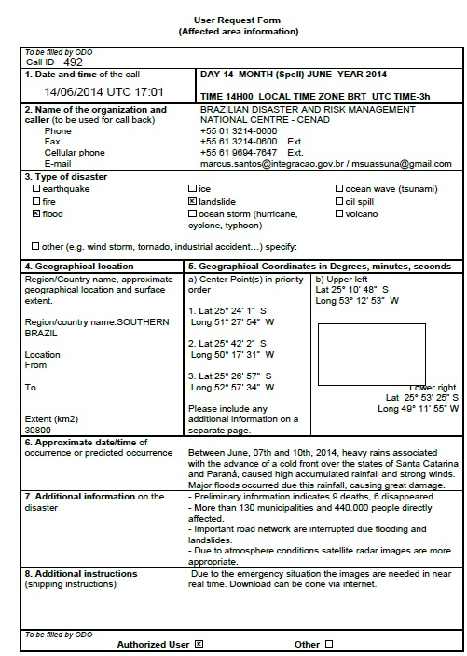
ECO on-duty
Name |  | María Elena Quiroga, Walter Andrés Fuster
Agency |  | CONAE
Phone |  | +54 3547 426766/431006
Fax |  | +54 3547 431032/1046
Mail |  | charter@conae.gov.ar
AU
Name / Organization |  | BRAZILIAN DISASTER AND RISK MANAGEMENT  NATIONAL CENTRE - CENAD
Address
Phone |  | +55 61 3214-0600 / cell phone +55 61 9694-7647
Fax |  | +55 61 3214-0600
Mail |  | marcus.santos@integracao.gov.br / msuassuna@gmail.com
EU
Name / Organization |  | BRAZILIAN DISASTER AND RISK MANAGEMENT  NATIONAL CENTRE - CENAD
Address
Phone |  | +55 61 3214-0600 / cell phone +55 61 9694-7647
Fax |  | +55 61 3214-0600
Mail |  | marcus.santos@integracao.gov.br / msuassuna@gmail.com
Emergency type
Earthquake Flood Ice Storm / Hurricane
Fires Industrial danger Landslide Volcano
Other:
Area details
Area Name / Country |  | SOUTHERN BRAZIL
Map of interest: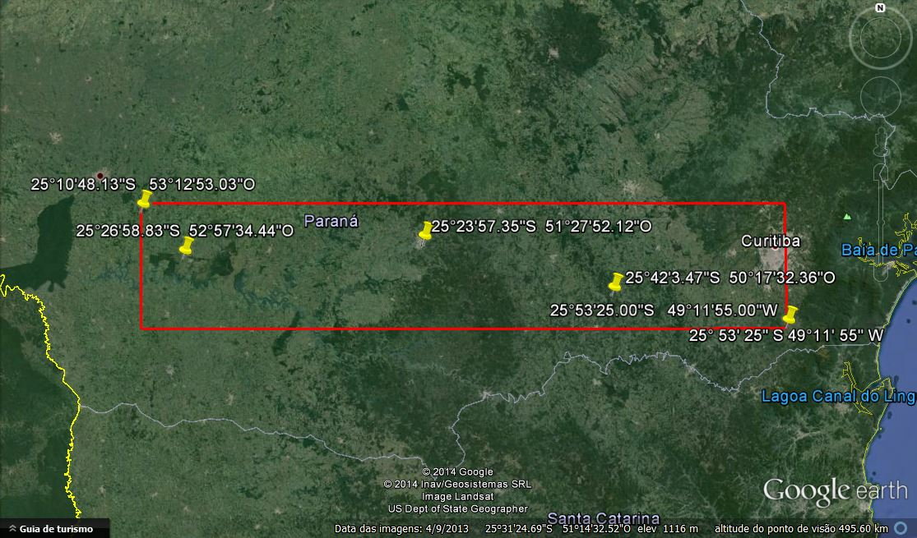

General Information on the event:
Between June, 07th and 10th, 2014, heavy rains associated
with the advance of a cold front over the states of Santa Catarina
and Paraná, caused high accumulated rainfall and strong winds.
Major floods occurred due this rainfall, causing great damage.

Information and preferences provided by Requester:

Acquisition & Archives Plan
Agency | Satellites |  |  | Program / Archive
CNES  ESA  CSA  ISRO  ISRO  CONAE  NOAA  USGS  DMCii  JAXA  CNSA & INPE  CNSA  DLR  KARI  ROSCOSMOS  ROSCOSMOS | PLEIADES SPOT5 SPOT4*  ENVISAT* ERS2*  RADARSAT  IRS-P5 Resourcesat-2 Oceansat-2  IRSP6 * Cartosat-2 Risat-2 IMS-1  SAC-C*  POES GOES  LANDSAT VHR Commercial  DMC MRI DMC VHRI  ALOS* KIBO HDTV-EF  CBERS*  SJ-9A  TerraSAR-X/TanDEM-X  KOMPSAT-2  Meteor-M Kanopus-V Resurs-P  Resurs-DK* |  |  | Pr. Ar.  Pr. Ar.  Pr. Ar.  Pr. Ar.  Pr. Ar.  Pr. Ar.  Pr. Ar.  Pr. Ar.  Pr. Ar.  Pr. Ar.  Pr. Ar.  Pr. Ar.  Pr. Ar.  Pr. Ar.  Pr. Ar.  Pr. Ar.
ERFs:
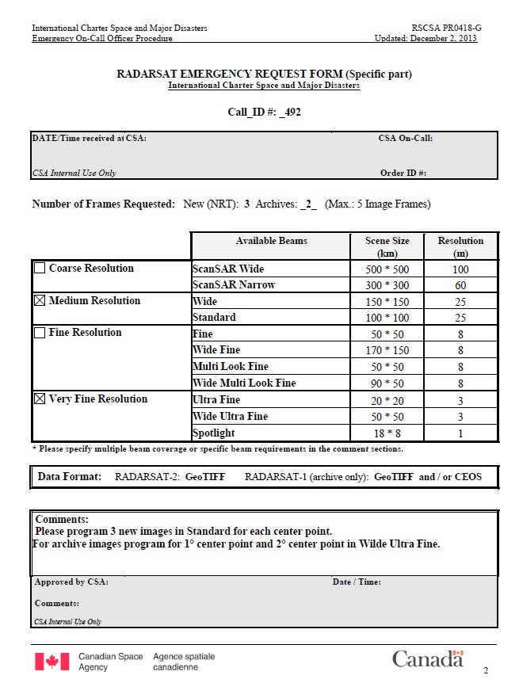

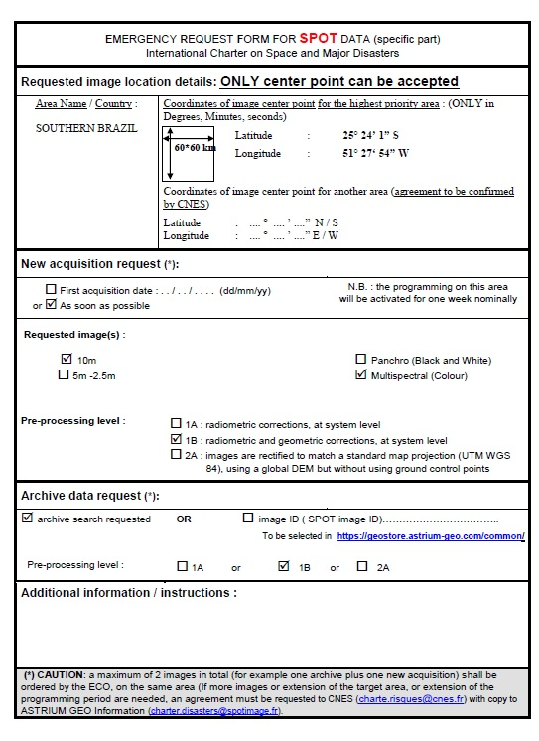

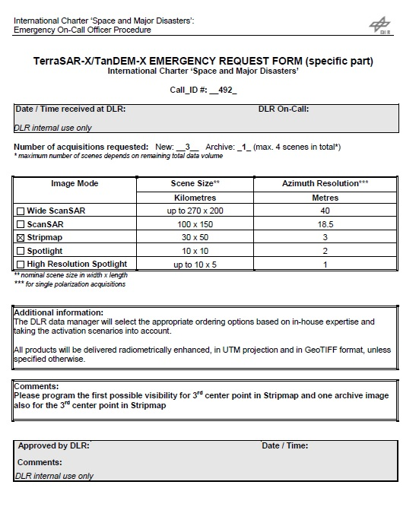
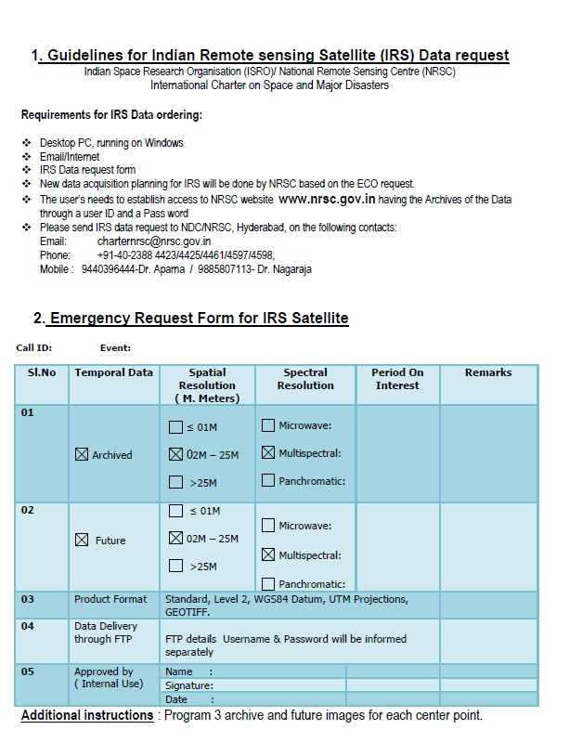

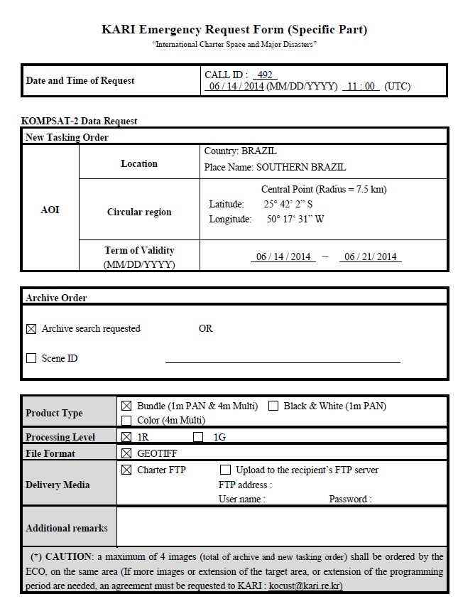

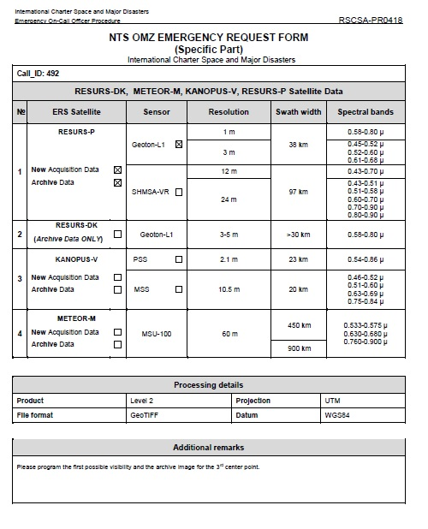
*Only archive images are available EUMETSAT data of Meteosat and Metop satellites do not need to be tasked by ECO. For relevant scenarios EUMETSAT will provide imagery to the PM in support of a Call. PMs may request additional data from EUMETSAT as needed.

