International Charter
Space and Major Disasters

Charter Activation | 595
Charter Call ID | 685
Disaster Event | Flood
Disaster Location | BRAZIL
Date of Final Reporting | 2019.04.24

PM Report

*Reporting forms completed by: Lucas Mikosz

*Reporting forms reviewed by:

Project Managers for Charter activations are expected to provide the PM report to the Charter Executive Secretariat within 45 days after the start of the activation.

A. Disaster Event Summary
*A1. Emergency type: | Flood
*A2. Date disaster initiated: 13 Jan 2019
*A3. Disaster location and extent: BRAZIL (~60 km2)
A4. Estimated number of deaths: 03
A5. Estimated number of people affected: 8496
A6. Estimated economic losses: not estimated
A7. Additional disaster impacts (environmental, infrastructure, etc): Flooded houses, dislodged people and agricultural damages
A8. Additional disaster event details: Heavy rains on the Ibiraputã river affected the city of Alegrete and on the Ibicuí river affected the city of Manoel Viana. The Ibirapuitã merge with Ibicuí and then with Uruguay river. The combination of flood waves affected the downstream city of Uruguaiana,

* mandatory

B. Activation Information Charter Call ID685
*B1. Date of Charter activation 13 Jan 2019
*B2. Geographical Coordinates (Lat - Long)
Bounding Box: | Upper left corner: |  | Centre Point(s): |  | (1): centerPoint_1  S 29°47', W 55°47', radius: 4
 | Upper right corner: |  |  |  | (2): centerPoint_2  S 29°35', W 55°29', radius: 4
 | Lower left corner: |  |  |  | (3): centerPoint_3  S 29°45', W 57°5', radius: 10
 | Lower right corner:
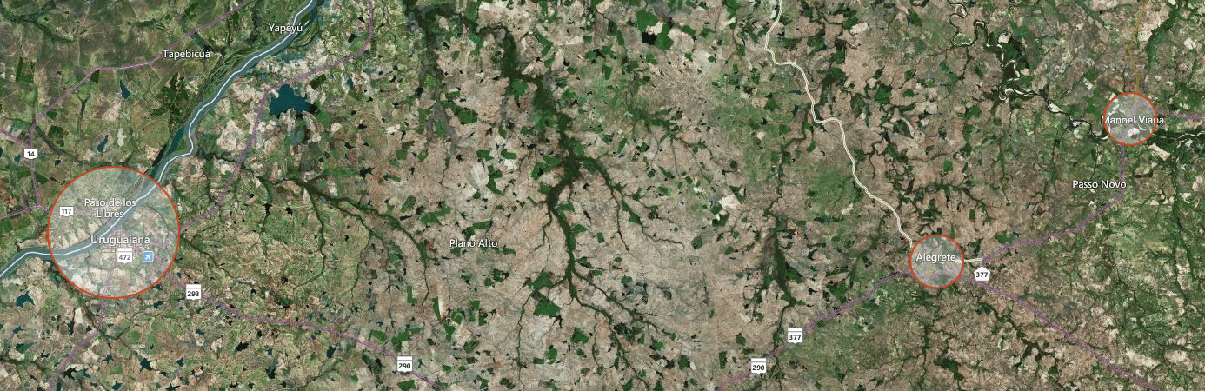
*B3. Authorized User/Requestor: Lucas Mikosz |  | *Organization: CENAD |  | *AU contacted ODO: 13 Jan 2019
B4. On behalf: |  | Organization:
*B5. ECO: Hendrik Zwenzner |  | *Organization: DLR |  | *ECO contacted PM: 13 Jan 2019 19:26
*B6. Project Manager: Lucas Mikosz |  | *Organization: INPE |  | *PM nominated: 13 Jan 2019 19:16  By: INPE
B7. Value-adding Reseller or organization(s): CENAD |  |  |  | First images available:  • First archive (pre-event) image(s) (dd mmm yyyy): 14 Jan 2019  • First crisis (post-event) image(s) (dd mmm yyyy): 14 Jan 2019
*B8. End User(s): |  | *Organization: National Center of Risk and Disaster Management,  Geological Service of Brazil. |  | • Date of first Value-adding (VA) products (e.g. maps and charts from the PM or VAR) based on archive image (dd mmm yyyy):  15 Jan 2019  • Date of first VA crisis product** (dd mmm yyyy) delivered to End User: 15 Jan 2019  **can be a product based on both archive and crisis images.

* mandatory

C. Intervention Summary
*C1. Describe the activation in detail and describe the interaction between the PM and the AU:
* The type(s) and acquisition date(s) of the first post-event (crisis) image(s) received from the Charter:
* The type and acquisition date of the first post-event (crisis) image that was used to generate a VA product:
* The date the first VA crisis product was generated:
*C2. Provide a chronology of events associated with the disaster and the Charter activation: -
Call 685:
ODO confirmation, ECO call notification on 13 Jan 2019 18:34
ECO URF validation on 13 Jan 2019 19:00
ERF v.1.0 sent to MPP of CSA on 13 Jan 2019 19:13
ERF v.1.0 sent to MPP of ROSCOSMOS on 13 Jan 2019 19:14
ERF v.1.0 sent to MPP of JAXA on 13 Jan 2019 19:14
ERF v.1.0 sent to MPP of ESA on 13 Jan 2019 19:14
ERF v.1.0 sent to MPP of CNES on 13 Jan 2019 19:14
ERF v.1.0 sent to MPP of INPE on 13 Jan 2019 19:14
ERF v.1.0 sent to MPP of PLANET on 13 Jan 2019 19:14
ERF v.1.0 sent to MPP of DLR on 13 Jan 2019 19:14
ERF v.1.0 sent to MPP of USGS on 13 Jan 2019 19:14
ERF v.1.0 sent to MPP of KARI on 13 Jan 2019 19:14
PM nominated by INPE on 13 Jan 2019 19:16
ERF v.1.0 sent to MPP of CNSA on 13 Jan 2019 19:18
ECO Dossier completed on 13 Jan 2019 19:26
ECO Dossier validated by PM on 13 Jan 2019 19:42
AAP received from MPP of ROSCOSMOS on 13 Jan 2019 20:02
AAP received from MPP of ROSCOSMOS on 13 Jan 2019 20:02
AAP received from MPP of ROSCOSMOS on 13 Jan 2019 20:02
AAP received from MPP of DLR on 13 Jan 2019 22:02
AAP received from MPP of DLR on 13 Jan 2019 22:03
AAP received from MPP of KARI on 14 Jan 2019 07:08
AAP received from MPP of KARI on 14 Jan 2019 07:08
AAP received from MPP of KARI on 14 Jan 2019 07:08
AAP received from MPP of KARI on 14 Jan 2019 07:08
Data Product received from MPP of ESA on 14 Jan 2019 18:30
Data Product received from MPP of CNES on 14 Jan 2019 21:04
VAP uploaded on 14 Jan 2019 21:12
Data Product received from MPP of ESA on 15 Jan 2019 00:00
Data Product received from MPP of ESA on 15 Jan 2019 00:00
Data Product received from MPP of KARI on 15 Jan 2019 02:01
Data Product received from MPP of KARI on 15 Jan 2019 02:02
Data Product received from MPP of KARI on 15 Jan 2019 02:03
Data Product received from MPP of KARI on 15 Jan 2019 02:04
Data Product received from MPP of KARI on 15 Jan 2019 02:04
AAP received from MPP of JAXA on 15 Jan 2019 04:45
Data Product received from MPP of INPE on 15 Jan 2019 11:57
Data Product received from MPP of INPE on 15 Jan 2019 12:09
Data Product received from MPP of INPE on 15 Jan 2019 12:46
Data Product received from MPP of INPE on 15 Jan 2019 12:52
AAP received from MPP of ESA on 15 Jan 2019 14:00
AAP received from MPP of ESA on 15 Jan 2019 14:00
AAP received from MPP of ESA on 15 Jan 2019 14:00
AAP received from MPP of ESA on 15 Jan 2019 14:00
Data Product received from MPP of INPE on 15 Jan 2019 17:23
Data Product received from MPP of INPE on 15 Jan 2019 17:35
VAP uploaded on 15 Jan 2019 21:10
Data Product received from MPP of ESA on 16 Jan 2019 00:00
Data Product received from MPP of ESA on 16 Jan 2019 00:00
VAP uploaded on 16 Jan 2019 19:28
VAP uploaded on 16 Jan 2019 20:09
Data Product received from MPP of USGS on 16 Jan 2019 23:50
Data Product received from MPP of USGS on 16 Jan 2019 23:50
Data Product received from MPP of USGS on 16 Jan 2019 23:50
Data Product received from MPP of USGS on 16 Jan 2019 23:50
Data Product received from MPP of USGS on 16 Jan 2019 23:51
Data Product received from MPP of USGS on 16 Jan 2019 23:51
Data Product received from MPP of USGS on 16 Jan 2019 23:51
Data Product received from MPP of USGS on 16 Jan 2019 23:51
Data Product received from MPP of USGS on 16 Jan 2019 23:51
Data Product received from MPP of USGS on 16 Jan 2019 23:52
Data Product received from MPP of USGS on 16 Jan 2019 23:55
Data Product received from MPP of USGS on 16 Jan 2019 23:55
Data Product received from MPP of USGS on 16 Jan 2019 23:55
Data Product received from MPP of USGS on 16 Jan 2019 23:55
Data Product received from MPP of USGS on 16 Jan 2019 23:56
Data Product received from MPP of USGS on 16 Jan 2019 23:56
Data Product received from MPP of USGS on 16 Jan 2019 23:56
Data Product received from MPP of USGS on 16 Jan 2019 23:57
Data Product received from MPP of USGS on 16 Jan 2019 23:57
Data Product received from MPP of USGS on 16 Jan 2019 23:57
Data Product received from MPP of USGS on 16 Jan 2019 23:58
Data Product received from MPP of USGS on 16 Jan 2019 23:58
Data Product received from MPP of USGS on 16 Jan 2019 23:58
Data Product received from MPP of USGS on 16 Jan 2019 23:58
Data Product received from MPP of USGS on 16 Jan 2019 23:59
Data Product received from MPP of USGS on 16 Jan 2019 23:59
Data Product received from MPP of USGS on 16 Jan 2019 23:59
Data Product received from MPP of USGS on 16 Jan 2019 23:59
Data Product received from MPP of JAXA on 17 Jan 2019 02:02
Data Product received from MPP of JAXA on 17 Jan 2019 02:13
Data Product received from MPP of ESA on 17 Jan 2019 11:00
Data Product received from MPP of INPE on 17 Jan 2019 12:58
Data Product received from MPP of INPE on 17 Jan 2019 13:09
VAP uploaded on 17 Jan 2019 19:04
Data Product received from MPP of ESA on 18 Jan 2019 16:30
Data Product received from MPP of CSA on 18 Jan 2019 19:28
AAP received from MPP of CSA on 18 Jan 2019 19:33
AAP received from MPP of CSA on 18 Jan 2019 19:33
Data Product received from MPP of KARI on 21 Jan 2019 08:31
Data Product received from MPP of KARI on 21 Jan 2019 08:32
Data Product received from MPP of USGS on 31 Jan 2019 18:14
Data Product received from MPP of USGS on 31 Jan 2019 18:15
Data Product received from MPP of USGS on 31 Jan 2019 18:15
Data Product received from MPP of USGS on 31 Jan 2019 18:15
Data Product received from MPP of USGS on 31 Jan 2019 18:16
Data Product received from MPP of USGS on 31 Jan 2019 18:16
Data Product received from MPP of USGS on 31 Jan 2019 18:16
Data Product received from MPP of USGS on 31 Jan 2019 18:16
Data Product received from MPP of USGS on 31 Jan 2019 18:17
Data Product received from MPP of USGS on 31 Jan 2019 18:17
*C3. Fill in the table below in order to include the data not received through COS-2. List the date (dd/mm/yyyy) that each image was collected).
Agency | Satellite Instrument Mode | Sensing dates of requested products | Date of: | Sensing / Reception dates of metadata / products
 |  |  |  | Attempt 1 | Attempt 2 | Attempt 3 | Archive
CNES | PLEIADES  PHR1A | 14 Jan 2019 | Reception | 14 jan 2019
 |  |  | Sensing | 14 jan 2019
CNES | PLEIADES  PHR1B | 16 Jan 2019 | Reception | 24 Jan 2019
 |  |  | Sensing | 16 Jan 2019
CNES | PLEIADES  PHR1A | 21 Jan 2019 | Reception | 21 Jan 2019
 |  |  | Sensing | 21 Jan 2019
CNES | PLEIADES  PHR1A | 21 Jan 2019 | Reception | 21 Jan 2019
 |  |  | Sensing | 21 Jan 2019
CNES | PLEIADES  PHR1B | 20 Jan 2019 | Reception | 20 Jan 2019
 |  |  | Sensing | 20 Jan 2019
CNES | PLEIADES  PHR1B | 20 Jan 2019 | Reception | 20 Jan 2019
 |  |  | Sensing | 20 Jan 2019
CNES | PLEIADES  PHR1B | 20 Jan 2019 | Reception | 20 Jan 2019
 |  |  | Sensing | 20 Jan 2019
CNES | PLEIADES  PHR1A | 19 Jan 2019 | Reception | 19 Jan 2019
 |  |  | Sensing | 19 Jan 2019
CNES | PLEIADES  PHR1A | 19 Jan 2019 | Reception | 19 Jan 2019
 |  |  | Sensing | 19 Jan 2019
CNES | PLEIADES  PHR1A | 19 Jan 2019 | Reception | 19 Jan 2019
 |  |  | Sensing | 19 Jan 2019
CNES | PLEIADES  PHR1B | 18 Jan 2019 | Reception | 18 Jan 2019
 |  |  | Sensing | 18 Jan 2019
CNES | PLEIADES  PHR1B | 18 Jan 2019 | Reception | 18 Jan 2019
 |  |  | Sensing | 18 Jan 2019
CNES | PLEIADES  PHR1A | 17 Jan 2019 | Reception | 17 Jan 2019
 |  |  | Sensing | 17 Jan 2019
CNES | PLEIADES  PHR1A | 17 Jan 2019 | Reception | 17 Jan 2019
 |  |  | Sensing | 17 Jan 2019
CNES | PLEIADES  PHR1B | 17 Jan 2019 | Reception | 17 Jan 2019
 |  |  | Sensing | 17 Jan 2019
CNES | PLEIADES  PHR1B | 16 Jan 2019 | Reception | 16 Jan 2019
 |  |  | Sensing | 16 Jan 2019
CNES | PLEIADES  PHR1B | 16 Jan 2019 | Reception | 16 Jan 2019
 |  |  | Sensing | 16 Jan 2019
CNES | PLEIADES  PHR1B | 16 Jan 2019 | Reception | 16 Jan 2019
 |  |  | Sensing | 16 Jan 2019
CNES | PLEIADES  PHR1A | 15 Jan 2019 | Reception | 15 Jan 2019
 |  |  | Sensing | 15 Jan 2019
CNES | PLEIADES  PHR1A | 15 Jan 2019 | Reception | 15 Jan 2019
 |  |  | Sensing | 15 Jan 2019
CNES | PLEIADES  PHR1A | 15 Jan 2019 | Reception | 15 Jan 2019
 |  |  | Sensing | 15 Jan 2019
USGS | WORLDVIEW1  EO_IMAGER | 24 Jan 2019 | Reception | 31 Jan 2019
 |  |  | Sensing | 24 Jan 2019
USGS | WORLDVIEW1  EO_IMAGER | 24 Jan 2019 | Reception | 31 Jan 2019
 |  |  | Sensing | 24 Jan 2019
USGS | WORLDVIEW1  EO_IMAGER | 24 Jan 2019 | Reception | 31 Jan 2019
 |  |  | Sensing | 24 Jan 2019
USGS | WORLDVIEW1  EO_IMAGER | 24 Jan 2019 | Reception | 31 Jan 2019
 |  |  | Sensing | 24 Jan 2019
USGS | WORLDVIEW2  EO_IMAGER | 29 Jan 2019 | Reception | 31 Jan 2019
 |  |  | Sensing | 29 Jan 2019
USGS | WORLDVIEW2  EO_IMAGER | 29 Jan 2019 | Reception | 31 Jan 2019
 |  |  | Sensing | 29 Jan 2019
USGS | WORLDVIEW2  EO_IMAGER | 29 Jan 2019 | Reception | 31 Jan 2019
 |  |  | Sensing | 29 Jan 2019
USGS | WORLDVIEW2  EO_IMAGER | 29 Jan 2019 | Reception | 31 Jan 2019
 |  |  | Sensing | 29 Jan 2019
USGS | WORLDVIEW2  EO_IMAGER | 29 Jan 2019 | Reception | 31 Jan 2019
 |  |  | Sensing | 29 Jan 2019
USGS | WORLDVIEW2  EO_IMAGER | 29 Jan 2019 | Reception | 31 Jan 2019
 |  |  | Sensing | 29 Jan 2019
USGS | WORLDVIEW2  EO_IMAGER | 08 Dec 2018 | Reception |  |  |  | 16 Jan 2019
 |  |  | Sensing |  |  |  | 08 Dec 2018
USGS | WORLDVIEW2  EO_IMAGER | 08 Dec 2018 | Reception |  |  |  | 16 Jan 2019
 |  |  | Sensing |  |  |  | 08 Dec 2018
USGS | WORLDVIEW2  EO_IMAGER | 22 Nov 2018 | Reception |  |  |  | 16 Jan 2019
 |  |  | Sensing |  |  |  | 22 Nov 2018
USGS | WORLDVIEW2  EO_IMAGER | 08 Dec 2018 | Reception |  |  |  | 16 Jan 2019
 |  |  | Sensing |  |  |  | 08 Dec 2018
USGS | WORLDVIEW2  EO_IMAGER | 22 Nov 2018 | Reception |  |  |  | 16 Jan 2019
 |  |  | Sensing |  |  |  | 22 Nov 2018
USGS | WORLDVIEW2  EO_IMAGER | 22 Nov 2018 | Reception |  |  |  | 16 Jan 2019
 |  |  | Sensing |  |  |  | 22 Nov 2018
USGS | WORLDVIEW2  EO_IMAGER | 08 Dec 2018 | Reception |  |  |  | 16 Jan 2019
 |  |  | Sensing |  |  |  | 08 Dec 2018
USGS | WORLDVIEW2  EO_IMAGER | 22 Nov 2018 | Reception |  |  |  | 16 Jan 2019
 |  |  | Sensing |  |  |  | 22 Nov 2018
USGS | GEO_EYE_1 EO_IMAGER | 07 Jun 2018 | Reception |  |  |  | 16 Jan 2019
 |  |  | Sensing |  |  |  | 07 Jun 2018
USGS | GEO_EYE_1 EO_IMAGER | 07 Jun 2018 | Reception |  |  |  | 16 Jan 2019
 |  |  | Sensing |  |  |  | 07 Jun 2018
USGS | GEO_EYE_1 EO_IMAGER | 07 Jun 2018 | Reception |  |  |  | 16 Jan 2019
 |  |  | Sensing |  |  |  | 07 Jun 2018
USGS | GEO_EYE_1 EO_IMAGER | 07 Jun 2018 | Reception |  |  |  | 16 Jan 2019
 |  |  | Sensing |  |  |  | 07 Jun 2018
USGS | GEO_EYE_1 EO_IMAGER | 07 Jun 2018 | Reception |  |  |  | 16 Jan 2019
 |  |  | Sensing |  |  |  | 07 Jun 2018
USGS | GEO_EYE_1 EO_IMAGER | 07 Jun 2018 | Reception |  |  |  | 16 Jan 2019
 |  |  | Sensing |  |  |  | 07 Jun 2018
USGS | GEO_EYE_1 EO_IMAGER | 29 Nov 2018 | Reception |  |  |  | 16 Jan 2019
 |  |  | Sensing |  |  |  | 29 Nov 2018
USGS | GEO_EYE_1 EO_IMAGER | 29 Nov 2018 | Reception |  |  |  | 16 Jan 2019
 |  |  | Sensing |  |  |  | 29 Nov 2018
USGS | GEO_EYE_1 EO_IMAGER | 29 Nov 2018 | Reception |  |  |  | 16 Jan 2019
 |  |  | Sensing |  |  |  | 29 Nov 2018
USGS | GEO_EYE_1 EO_IMAGER | 29 Nov 2018 | Reception |  |  |  | 16 Jan 2019
 |  |  | Sensing |  |  |  | 29 Nov 2018
USGS | LANDSAT 7  ETM | 20 Nov 2018 | Reception |  |  |  | 16 Jan 2019
 |  |  | Sensing |  |  |  | 20 Nov 2018
USGS | LANDSAT 7  ETM | 28 Oct 2018 | Reception |  |  |  | 16 Jan 2019
 |  |  | Sensing |  |  |  | 28 Oct 2018
USGS | LANDSAT 7  ETM | 28 Oct 2018 | Reception |  |  |  | 16 Jan 2019
 |  |  | Sensing |  |  |  | 28 Oct 2018
USGS | LANDSAT 7  ETM | 20 Nov 2018 | Reception |  |  |  | 16 Jan 2019
 |  |  | Sensing |  |  |  | 20 Nov 2018
USGS | LANDSAT 7  ETM | 16 Jan 2019 | Reception | 16 Jan 2019
 |  |  | Sensing | 16 Jan 2019
USGS | LANDSAT 7  ETM | 16 Jan 2019 | Reception | 16 Jan 2019
 |  |  | Sensing | 16 Jan 2019
USGS | LANDSAT 8  OLI_TIRS | 28 Nov 2018 | Reception |  |  |  | 16 Jan 2019
 |  |  | Sensing |  |  |  | 28 Nov 2018
USGS | LANDSAT 8  OLI_TIRS | 28 Nov 2018 | Reception |  |  |  | 16 Jan 2019
 |  |  | Sensing |  |  |  | 28 Nov 2018
USGS | LANDSAT 8  OLI_TIRS | 07 Dec 2018 | Reception |  |  |  | 16 Jan 2019
 |  |  | Sensing |  |  |  | 07 Dec 2018
USGS | LANDSAT 8  OLI_TIRS | 07 Dec 2018 | Reception |  |  |  | 16 Jan 2019
 |  |  | Sensing |  |  |  | 07 Dec 2018
INPE | CBER-4 panMUX | 16 Jan 2019 | Reception | 17 Jan 2019
 |  |  | Sensing | 16 Jan 2019
INPE | CBER-4 panMUX | 16 Jan 2019 | Reception | 17 Jan 2019
 |  |  | Sensing | 16 Jan 2019
INPE | CBER-4 panMUX | 02 Jan 2019 | Reception |  |  |  | 15 Jan 2019
 |  |  | Sensing |  |  |  | 02 Jan 2019
INPE | CBER-4 panMUX | 02 Jan 2019 | Reception |  |  |  | 15 Jan 2019
 |  |  | Sensing |  |  |  | 02 Jan 2019
INPE | CBER-4 panMUX | 04 Feb 2018 | Reception |  |  |  | 15 Jan 2019
 |  |  | Sensing |  |  |  | 04 Feb 2018
INPE | CBER-4 panMUX | 04 Feb 2018 | Reception |  |  |  | 15 Jan 2019
 |  |  | Sensing |  |  |  | 04 Feb 2018
INPE | CBER-4 panMUX | 04 Feb 2018 | Reception |  |  |  | 15 Jan 2019
 |  |  | Sensing |  |  |  | 04 Feb 2018
INPE | CBER-4 panMUX | 04 Feb 2018 | Reception |  |  |  | 15 Jan 2019
 |  |  | Sensing |  |  |  | 04 Feb 2018
CSA | RADARSAT2 SAR_RAD_2 ULTRA_FINE | (Archive) 13 Jan 2017 | Reception |  |  |  | 18 Jan 2019
 |  |  | Sensing |  |  |  | 13 Jan 2017
CSA | RADARSAT2 SAR_RAD_2 ULTRA_FINE | (Archive) 01 Mar 2017 | Reception |  |  |  | 18 Jan 2019
 |  |  | Sensing |  |  |  | 01 Mar 2017
CSA | RADARSAT2 SAR_RAD_2 ULTRA_FINE | 16 Jan 2019 | Reception | 18 Jan 2019
 |  |  | Sensing | 16 Jan 2019
CSA | RADARSAT2 SAR_RAD_2 ULTRA_FINE | 17 Jan 2019 | Reception | 18 Jan 2019
 |  |  | Sensing | 17 Jan 2019
DLR | TERRASAR_X SAR_DLR SM | 17 Jan 2019 | Reception | 13 Jan 2019
 |  |  | Sensing | 17 Jan 2019
DLR | TERRASAR_X SAR_DLR SM | 17 Jan 2019 | Reception | 13 Jan 2019
 |  |  | Sensing | 17 Jan 2019
ESA | SENTINEL_1 SAR IWS | 14 Jan 2019 | Reception | 15 Jan 2019
 |  |  | Sensing | 14 Jan 2019
ESA | SENTINEL_1 SAR IWS | 14 Jan 2019 | Reception | 15 Jan 2019
 |  |  | Sensing | 14 Jan 2019
ESA | SENTINEL_1 SAR IWS | 15 Jan 2019 | Reception | 15 Jan 2019
 |  |  | Sensing | 15 Jan 2019
ESA | SENTINEL_1 SAR IWS | 16 Jan 2019 | Reception | 15 Jan 2019
 |  |  | Sensing | 16 Jan 2019
ESA | SENTINEL_1 SAR IWS | 17 Jan 2019 | Reception | 15 Jan 2019
 |  |  | Sensing | 17 Jan 2019
ESA | SENTINEL_1 SAR IWS | 18 Jan 2019 | Reception | 15 Jan 2019
 |  |  | Sensing | 18 Jan 2019
ESA | SENTINEL_1 SAR IWS | 18 Jan 2019 | Reception | 15 Jan 2019
 |  |  | Sensing | 18 Jan 2019
ESA | SENTINEL_1B SAR IWS | 06 Jan 2019 | Reception |  |  |  | 14 Jan 2019
 |  |  | Sensing |  |  |  | 06 Jan 2019
JAXA | ALOS2 PALSAR2 SM | 15 Jan 2019 | Reception | 15 Jan 2019
 |  |  | Sensing | 15 Jan 2019
JAXA | ALOS2 PALSAR2 SM | 15 Jan 2019 | Reception | 15 Jan 2019
 |  |  | Sensing | 15 Jan 2019
JAXA | ALOS2 PALSAR2 SM | 15 Jan 2019 | Reception | 15 Jan 2019
 |  |  | Sensing | 15 Jan 2019
KARI | KOMPSAT2 MSC PMS | (Archive) 15 Apr 2018 | Reception |  |  |  | 14 Jan 2019
 |  |  | Sensing |  |  |  | 15 Apr 2018
KARI | KOMPSAT2 MSC PMS | (Archive) 07 Aug 2018 | Reception |  |  |  | 15 Jan 2019
 |  |  | Sensing |  |  |  | 07 Aug 2018
KARI | KOMPSAT2 MSC PMS | (Archive) 17 Mar 2017 | Reception |  |  |  | 15 Jan 2019
 |  |  | Sensing |  |  |  | 17 Mar 2017
KARI | KOMPSAT5 COSI ST | (Archive) 21 Jun 2017 | Reception |  |  |  | 15 Jan 2019
 |  |  | Sensing |  |  |  | 21 Jun 2017
KARI | KOMPSAT2 MSC PMS | 15 Jan 2019 | Reception | 14 Jan 2019
 |  |  | Sensing | 15 Jan 2019
KARI | KOMPSAT3 AEISS PMS | 16 Jan 2019 | Reception | 14 Jan 2019
 |  |  | Sensing | 16 Jan 2019
KARI | KOMPSAT5 COSI ST | 18 Jan 2019 | Reception | 14 Jan 2019
 |  |  | Sensing | 18 Jan 2019
KARI | KOMPSAT5 COSI ST | 19 Jan 2019 | Reception | 21 Jan 2019
 |  |  | Sensing | 19 Jan 2019
ROSCOSMOS | RESURS_P GEOTON_1 | 15 Jan 2019 | Reception | 13 Jan 2019
 |  |  | Sensing | 15 Jan 2019
ROSCOSMOS | RESURS_P GEOTON_1 | 18 Jan 2019 | Reception | 13 Jan 2019
 |  |  | Sensing | 18 Jan 2019
ROSCOSMOS | RESURS_P GEOTON_1 | 21 Jan 2019 | Reception | 13 Jan 2019
 |  |  | Sensing | 21 Jan 2019
*C4. Fill in the table below identifying the available value added product data.
Title |  | Source |  | Acquired | Received | Copyright
Areas affected by flood in the city of Uruguaiana, Rio Grande do Sul, Brazil |  |  |  | 17 Jan 2019 | 17 Jan 2019
Areas affected by flood in the city of Uruguaiana, Rio Grande do Sul, Brazil |  |  |  | 16 Jan 2019 | 16 Jan 2019
Areas affected by flood in Manoel Viana City, Rio Grande do Sul, Brazil |  |  |  | 16 Jan 2019 | 16 Jan 2019
Areas affected by floods is Uruguaiana/RS |  |  |  | 15 Jan 2019 | 15 Jan 2019
Areas affected by flood in Alegrete City, Rio Grande do Sul, Brazil |  |  |  | 14 Jan 2019 | 14 Jan 2019

* mandatory

D. Intervention Assessment

D1. Usefulness of data provided by the Charter

*D1.1 Did the post-disaster data ordered by the ECO (prescribed data) meet your expectations? (Indicate your level of satisfaction by placing an [X] in the appropriate box)

Service | Fully  Satisfied | Partially  Satisfied | Not  Satisfied
a. Range/type of data (optical, radar) | x
b. Volume of data provided (duplication of type, physical volumes) | x
c. Coverage (visibility of area of interest) | x
d. Timeliness of data delivery | x
e. Data format | x
f. Not applicable post-disaster data was not provided

*D1.2 Did the pre-disaster data ordered by the ECO (prescribed data) meet your expectations? (Indicate your level of satisfaction by placing an [X] in the appropriate box)

Service | Fully  Satisfied | Partially  Satisfied | Not  Satisfied
a. Range/type of data (optical, radar) | x
b. Volume of data provided (duplication of type, physical volumes) | x
c. Coverage (visibility of area of interest) | x
d. Timeliness of data delivery | x
e. Data format | x
f. Not applicable post-disaster data was not provided

*D1.3 If you requested additional Charter data, did these data meet your expectations? (Indicate your level of satisfaction by placing an [X] in the appropriate box):

Service | Fully  Satisfied | Partially  Satisfied | Not  Satisfied
a. Range/type of data (optical, radar) | x
b. Volume of data provided (duplication of type, physical volumes) | x
c. Coverage (visibility of area of interest) | x
d. Timeliness of data delivery | x
e. Data format | x
f. Not applicable post-disaster data was not provided

D1.4 If you were not fully satisfied with the Charter data, please provide further details:

D1.5 If you did not use data provided by the Charter, please explain why they were not used:

Most of the post event data was used. We had some issues with images acquired outside area of interest, but the situation was reported directly to the Charter member involved.

D1.6 Were satellite data from outside the Charter used to support this event? If so, please indicate the type of data and their source

No.

D2. Usefulness of value adding service provided through the Charter

*D2.1 List the value-added products obtained from the Charter data:

a. Shape files
b. Image files
c. Web mapping services
d. Others, please state

*D2.2 How useful do you think the value-added products were for the end user(s)? (Indicate the level of usefulness by placing an [X] in the appropriate box):

a. Very useful
b. Partially useful | X
c. Not so useful
d. Unknown

D2.3 If you believe the value-added products were not so useful, please explain why:

At some of the AOIs, the flooded areas are narrow strips within urban areas, and was difficult to pinpoint the precise extension of the affected areas.

*D2.4 If known, how were the value-added products used by the end user(s)? (Indicate the use by placing an [X] in the appropriate boxes):

a. Operations | x
b. Planning
c. Communication
d. Documentation | x
e. Lessons | x
f. Not used
g. Unknown
h. Other

D2.5 How could the value added products be improved to make them more useful for the end user(s)?

VA products optimized to be displayed on end user’s cellphones.

D3. Assessment of overall Charter process in support of this call

*D3.1 Did the following steps in the Charter process meet with your expectations? (Indicate your level of satisfaction by placing an [X] in the appropriate box):

Service | Fully  Satisfied | Partially  Satisfied | Not  Satisfied
a. Assignment of PM (e.g. role acknowledgement, PM Welcome Package) | x
b. Communication with the ECO (e.g. Delivery of ECO Dossier) | x
c. Interface between the PM and Order Desks (if applicable) | x
d. Performing licensing / signature of NDAs | x
e. Interface between the PM and the End User(s) | x
f. Interface between the PM and ES | x
g. Interface between the PM and VA | x
h. Use of the COS-2 system | x

*D3.2 If you had to accept licensing terms and conditions / sign Non-Disclosure Agreements during this Charter call, did the procedure run smoothly?

a. Yes | x
b. No
c. Not applicable

If you experienced problems during the process, please provide further details:

No problems to report

D3.3 If you were not satisfied with any step in the Charter process, please let us know why:

D4. Additional comments, questions, observations, and lessons learned:

D5. End User Feedback

Attach a copy of user feedback forms (Annex G) submitted by the end users or email correspondence regarding the end user(s).

E. Supporting Documentation
*E1. Provide samples of media coverage of the disaster event from TV, radio, newspapers, websites, etc. Where possible, copy the content of the article into the PM report rather than only the web addresses:

From:
http://floodlist.com/america/argentina-brazil-uruguay-floods-january-2019

[report]

Argentina, Brazil, Uruguay – 4 Killed in Storms and Floods, Rivers Rising After Record Rainfall
10 January, 2019 by Richard Davies in Americas, News
At least 3 people have died in flooding and storms that have affected several provinces of Argentina over the last few days.
Heavy rain and flooding was reported in Corrientes, Tucumán, Santa Fe and Chaco, while strong winds caused damage in Santiago del Estero. Record rainfall was recorded in Resistencia, Chaco.
Meanwhile authorities have warned that the Uruguay River could reach danger levels in Concordia, Entre Rios, Argentina.
The Uruguay River has already broken its banks upstream, causing flooding in the Brazilian state of Rio Grande do Sul, where some areas have recorded almost 500mm of rain in the last 3 days. Stormy weather has also caused at least one fatality in the state.
Heavy rain has also affected parts of Uruguay, including in the cities of Durazno and Sarandí del Yí, where the overflowing Yí river has prompted evacuations.

Argentina

Corrientes and Santiago del Estero
According to local media 2 people died when their car was swept away by flooding from an overflowing river in Paso de los Libres, Corrientes. A young child died as a result of falling trees in Santiago del Estero.

Tucumán
Flooding has caused damage to homes and roads in eastern pats of Tucumán. Local medai say that more than 450 families were affected in the towns of Finca Mayo, Las Cejas, Los Ralos, San José, Garmendia and La Florida.

Chaco
In Chaco, the mayor of Resistencia has described the flooding situation as catastrophic.
Record rain fell on 08 January, when Resistencia recorded 224 mm of rain beating the previous record high of 205.9 mm set in March, 1994. Authorities said that 180mm of rain fell in just 80 minutes. Around 90 families have been evacuated with a further 3,500 needing assistance.

Santa Fe
In Santa Fe, over 80 people have evacuated their homes in areas close to the border with Santiago del Estero and Chaco. Local media said that towns affected include Gregoria Pérez de Denis, Santa Margarita and Villa Minetti.

Entre Rios
Meanwhile the Uruguay River could reach danger levels in Concordia, Entre Rios, according to the Salto Grande Joint Technical Commission (CTM).
CTM forecast that levels could reach 11.2 metres, surpassing the 11 metres alert level, after heavy rain in river catchments since Monday 07 January, with further rain predicted.
Servicio Meteorológico Nacional (SMN) said that heavy rain on 07 January caused flooding in Irazusta and Larroque.

Brazil
Flooding has already been reported upstream along the Uruguay River in Uruguaiana municipality in the Brazilian state of Rio Grande do Sul. Levels of the river jumped from 4.36 metres on 09 January to 6.79 metres the following day.
MetSul said that 329.2 mm of rain fell in Uruguaiana in 24 hours to 09 January and a total of 497mm in 72 hours.
Levels of other rivers in the state are also increasing including the Ibirapuitã River which, as of 09 January, was already above flood level in Alegrete.
Strong winds have also affected the state. One man died after an uprooted tree fell on a house in Alegrete, according to local media.
Authorities say the severe weather in the state has left around 30 people displaced.

Uruguay
Heavy rain has also affected parts of Uruguay over the last few days.
The country’s Sistema Nacional de Emergencias (SNM) said that flooding and heavy rain prompted evacuations in the departments of Canelones (17), Florida (14), Río Negro (8) and Durazno (84).
The cities of Durazno and Sarandí del Yí in Durazno state are among the worst affected after the overflowing Yí river caused severe flooding.
On 10 January the river stood at 9.95 metres in the city of Durazno, up from 9.74m the previous day. At Sarandí del Yí levels have started to fall from 4.14m on 09 January to 3.61m the next day.

[/end of report]

*E2. Provide a copy of the value-added products here. Please insert copies into this document as .jpeg or other small file formats:

(next page)

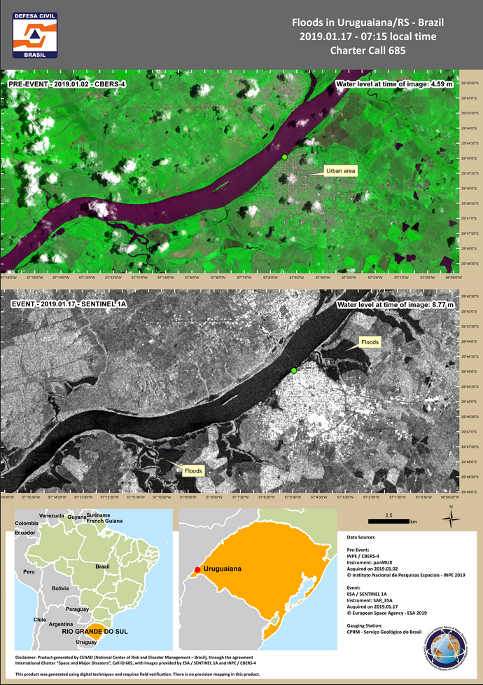

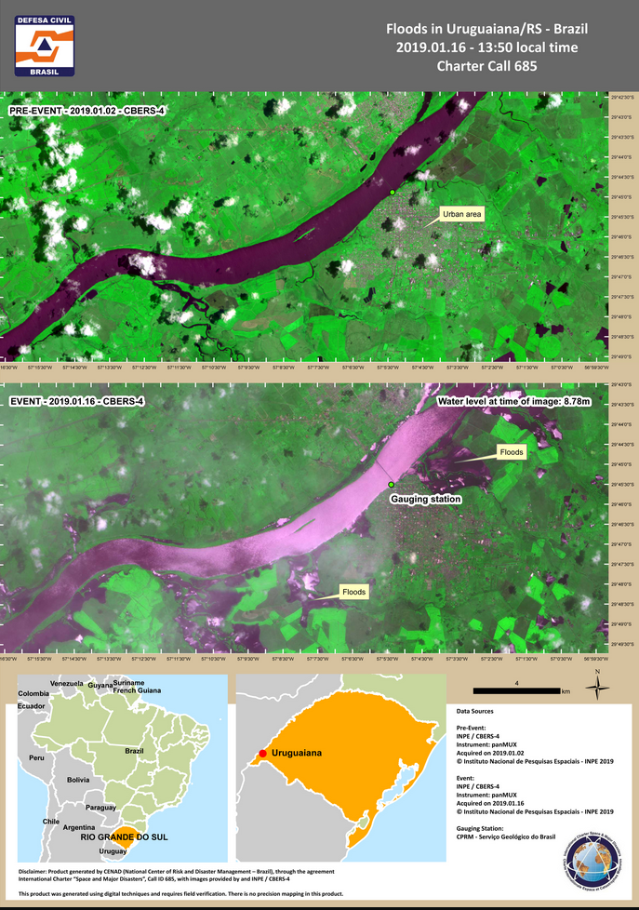

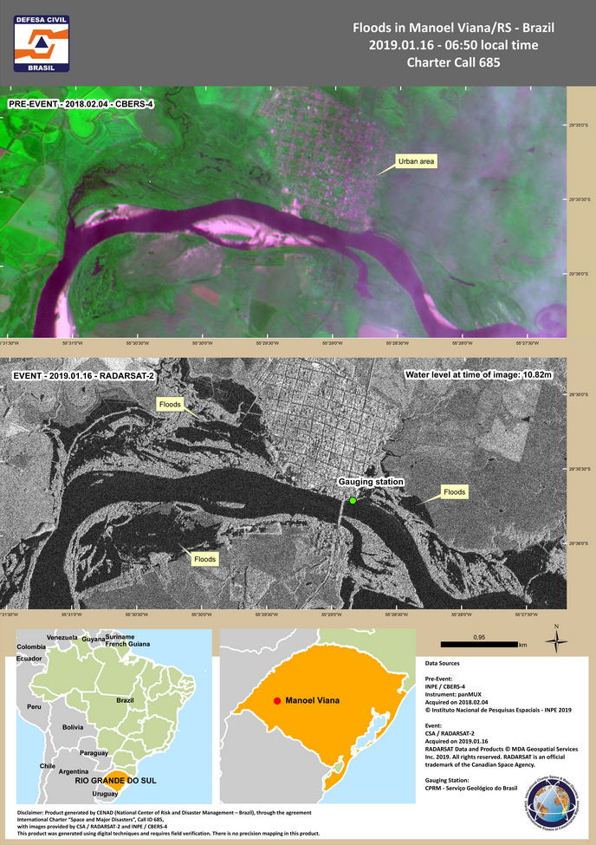

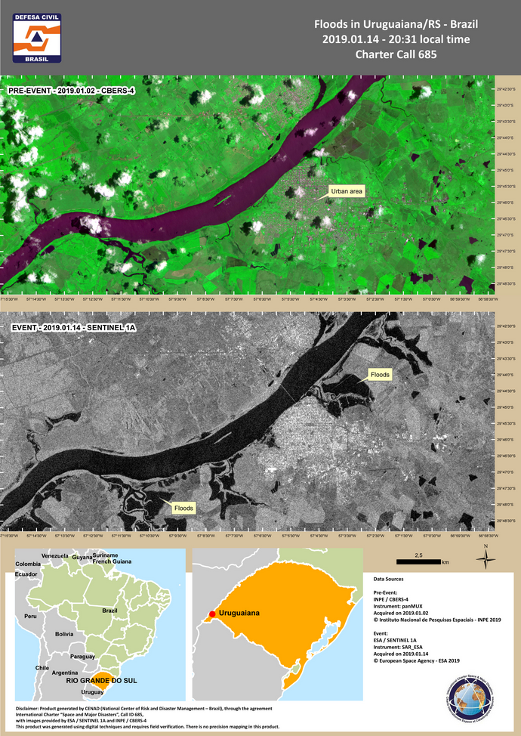

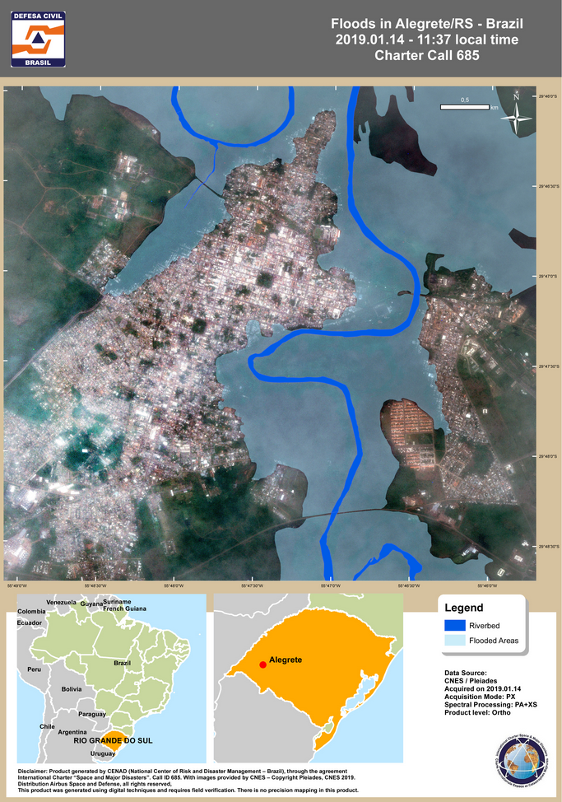

* mandatory

International Charter
Space and Major Disasters

End User Feedback Report

End User | CENAD
Organization | CENAD
Charter Call ID # | 685
Disaster Event | Flood
Disaster Location | Brazil, Rio Grande do Sul State.

Indicate your choice with an "_X_". (VG: Very Good, G: Good, R: Regular, B: Bad)
Please provide additional comments to explain your choices.

1a. Did you encounter difficulties in triggering the Charter? | Yes__ | No X
Comments:

1b. Did you use COS-2 to activate the Charter? | Yes X | No__
Comments:

1c. If you used COS-2 to activate the Charter, did you find it easy to use? | Yes X | No__
Comments: there was a problem with AU registration, but it was quickly solved

2. How was the communication with the Charter Officers and the Project Manager? | VG X | G__ | R__ | B__
Comments: EU and PM are the same institution

3. Did the delivered data and/or value-added products fulfill your request? | Yes X | Partly__ | No__
Comments:

4. Were the data and/or value-added products delivered in due time? | Yes X | No__
Comments:

5. Were data and/or value-added products delivered in an appropriate way? | Yes X | No__
Comments:

6. Were data and/or value-added products presented in an appropriate format? | Yes X | No__
Comments:

7. Was the information content relevant and accurate? | Yes X | No__
Comments:

8. How was the overall quality of the products delivered? | VG X | G__ | R__ | B__
Comments:

9. Did you use the data for:
Operations X | Communication | Planning | Documentation X
Lessons Learned / Training X | Other | Not used

10. Overall, the Charter contribution to this emergency was: | VG X | G__ | R__ | B__
Comments:

How could we improve the benefit of Charter activations for you?

