Using institutional arrangements and hybrid automata for regional scale agent-based modelling of land change
Abstract. This paper discusses the use of agent-based models for capturing land change in large frontier areas. Applying agent models in such areas is not straightforward, given the lack of data. To date, most agent based models of land frontiers study local areas using in-situ information. At regional scales, agent-based modellers need additional ways to describe collective decision-making. This paper presents two ideas to deal with the complexities of agent-based models at such scales: institutional arrangements and hybrid automata. Institutional arrangements help to model multi-agent interaction by explaining why, although there are rules and norms for land use, these rules are not always followed. A hybrid automaton combines a discrete state machine with continuous actions inside a state. This formalism captures states and transitions of agents in a simulation and helps to build expressive models. We validate our ideas by building a deforestation model in an area of 200,000 km² in Amazonia. Results show that we need to set different arrangements to capture changes in agents’ behaviour, as they react to external conditions. Thus, combining the ideas of institutional arrangements and hybrid automata improves the explanatory power of agent models for regional scales.
Keywords: agent-based models, land change, institutional arrangements, hybrid automata, frontier areas, deforestation, Amazonia.

Introduction
There are two main approaches in the literature for land change modelling, roughly split in pattern-based and agent-based models. Pattern-based models do not represent human behaviour directly. Such models detach the quantity of change (how much change is expected) from location of change (where changes are likely to take place). In general, pattern-based models have three parts: the demand, potential and allocation modules. Demand for change is external. A global demand for food can increase the need for agricultural areas. Each place has a potential for transition between land use types; this potential depends on the relative importance of driving forces of change. Demand is spatially allocated based on each place’s potential. Models that follow a pattern-based approach include CLUE (Veldkamp and Fresco 1996), CLUE-S (Verburg et al. 2002), GEOMOD2 (Pontius et al. 2001), and DINAMICA (Soares-Filho et al. 2002).
Agent-based models (ABM) aim to simulate how humans behave (Brown et al. 2005, Epstein 2006, Matthews et al. 2007). Going beyond the “rational decision making” logic of mainstream economics, these models try to capture the social contexts of human-decision making (Janssen and Ostrom 2006). In land change studies, agent-based models put farmers in a landscape. Their aim is to express their decisions on land use, their impacts in the environment, and the feedback of these impacts in further decisions (Parker et al. 2002)..
Using agent-based models in large area studies is hard. Since researchers need local data and field knowledge to create empirical models, most ABM studies cover small areas. Applying ABMs in large areas is not straightforward, especially in land change frontiers. Consider the case of tropical forests. Most tropical forests face major land change, increased deforestation and much greenhouse emissions. Yet, most tropical regions are frontier areas, where in-situ information does not exist or is hard to get. Local case studies are hard to extrapolate to regional scales. In these and similar cases, agent-based modellers need good methods to describe decision making in large areas.
Consider the case of the Brazilian Amazonia. Developers of agent-based models face a tough task there. Much change happens between two once-a-decade censuses. Farmers and loggers poach public land and land ownership data is hard to get. Shrewd entrepreneurs evolve from migrants to large farmers with the right connections. Poor migrants are settled in distant areas and used by loggers as a cover-up to extract wood illegally. Despite all these conflicts, the Brazilian Government was able to enforce the rule of law and to reduce deforestation by 75% in six years (2005-2011). Making sense of these different behaviours is not easy.
To deal with the complexities of ABMs in large frontier areas, this paper puts forward two ideas to model agent interaction and decision-making: institutional arrangements and hybrid automata. Combining the ideas of institutional arrangements and hybrid automata improves the explanatory power of ABMs for regional scales. In this paper, we explain how to use these ideas to design and build ABMs. To validate them, we put up a model for the area in Amazonia with the highest deforestation rate in the 1990s and 2000s. The model captures large-scale land change during the 2000s and is used to build scenarios until 2020.

Motivation and Previous Work
Our motivation to design ABMs for regional scales stems from our work on Brazilian Amazonia, an area of 4,100,000 km² where 720,000 km² have been deforested (INPE 2010). Occupation took place along the roads that connect the region to the Centre and South of Brazil, mostly in the states of Mato Grosso, Pará and Rondônia (Alves 2002, Becker 2005, Aguiar et al. 2007). From 1970 to 2005, 110,000 km² were deforested in Mato Grosso in the southern part of Amazonia, associated to migrant farmers coming from the South of Brazil. In 2008, Brazil produced 58 million tons of soybeans and Mato Grosso accounted for 15 million tons (25%). In Pará and Rondônia, cattle ranching prevails. The Brazilian herd grew from 147 million heads in 1990 to 200 million in 2007 to become the world’s largest commercial cattle herd. Most of this expansion (83%) took place in Amazonia by illegal poaching of public lands (Bowman et al. 2012).
Amazonia’s land is mostly state-owned and occupying it needs concessions. Brazilian law is also unusual in mandating private landowners in Amazonia to set aside 80% of their farms for forest preservation. In practice, poachers deforested public areas to earn tenure rights. They ignored the law, cutting much more than 20% of their land. The rule of law was not effective until 2005, when the Brazilian government started a large-scale effort to control deforestation. This lead to a significant drop in yearly deforestation rates, from 27,000 km² in 2004 to 6,500 km² in 2011 (INPE 2010). One of our research goals in land change modelling is to help us understand how so much change could happen so fast.
Most land change models for Amazonia use statistical analysis to link census data to deforestation rates. Laurance et al. (2002) used a nested grid of resolutions of 50 km × 50 km and 20 km × 20 km and found that population density, distance to roads, and dry season extension are the most likely causes of deforestation. Soares-Filho et al. (2010) showed that indigenous lands and protected areas restrained deforestation between 1997 and 2008. Using data from the 1996 Agricultural Census, Aguiar et al. (2007) split deforestation patterns into pasture, temporary and permanent agriculture. Using a grid of 25 km x 25 km, they found out that good connections to national markets are more relevant than distance to roads, and that large and medium farms have a higher impact than small ones.
Correlation-based are useful for explaining the present, but it is hard to use them to predict social reactions to public policies. Agent-based models (ABM) offer a valid alternative, as they can express complex behaviour and model social interactions. However, using ABMs in Amazonia or its sub-regions is challenging. Most ABMs for land use are based on fieldwork in small areas (Bousquet and Le Page 2004, Brown et al. 2005, Robinson et al. 2007) where researchers can have access to individualised information (Matthews et al. 2007). For example, Deadman et al. (2004) build a model to study family farms on 100-ha lots along the Transamazonia highway, west of Altamira, Brazil. The model describes behaviour of colonists with similar origins, but different household compositions and capital endowments. Valbuena et al. (2006) study a region of 600 km² in the Netherlands with 2700 agricultural holdings, focusing on external and internal factors that constrain farmers’ decisions. Farmer decision-making is modelled by probability distributions. However, when using ABMs in larger areas, it is hard to get first person accounts or to collect local statistics. In these cases, we need to make assumptions about collective behaviour and support them with field surveys and census data, as we show next.

Using Institutional Arrangements to Design Agent-Based Models
We hold that agent interactions are shaped by laws and conventions. In land management, there are rules and norms that limit the possible uses and tenure rights. However, these rules and norms are not followed at all times by all agents. We refer to institutional arrangements as deals set up between interest groups, social movements and state agencies to respond to rules and norms that are relevant to them (Dietz et al. 2003). These pacts define how agents manage natural resources (Scott and Meyer 1994). A farmer may switch between different arrangements as he reacts to external conditions. Agents’ decisions depend not only on existing rules and norms, but also on the institutional arrangements.
Some examples will clarify matters. Brazil’s Forest Code states that private farms in Amazonia have to keep 80% of their forest area intact. However, many farmers breached this rule without due punishment from the 1980s to the 2000s. An institutional arrangement bound illegal farmers, corrupt officials, and amoral politicians to form a coalition that protected them. From 2005 onwards, the Brazilian State increased its control actions. Farmers were forced to switch to a new arrangement that no longer protected lawbreakers. The rules did not change, but the institutional arrangements did.
Another example in Amazonia is the soy moratorium. This is a pact by soya exporters, farmers, Government and NGOs. To export his soybean production, a farmer has to abide by an informal norm: no more deforestation after 2006. Some farmers taking part on the moratorium may have cut more than 20% of their forest area before 2006. Although they broke official law, exporters buy their soy production if they are no longer cutting the forest. In this arrangement, an informal norm is more relevant than the formal rule.
To design ABMs using institutional arrangements, we use the following ideas:
- Agents: farmers that carry out land change. Agents own farms and have attributes such as capital, technology level and expansion aims.
- Spatial units (regular cells and farms): Regular cells describe the properties of space. Each cell has information on its land cover and land use and its spatial properties, such as distance to roads. Farms are irregular space partitions that belong to agents. A farm is linked to one of more cells.
- Rules and norms: we assign rules and norms to the spatial units, according to the legislation and to local practices.
- Institutional arrangements: we identify arrangements valid in the study area and set out their time range.
- Strategies: a set of consistent actions and decisions on land use. Each agent (or group of agents) chooses one strategy at a time, which she can change later. Examples of strategies include land speculation, intensive farming, and subsistence agriculture.
Figure 1 shows how these ideas are related. First, we select the study area, divide it in regular cells and assign their properties. We find out what rules and norms apply to this space. Then we describe the institutional arrangements that exist in each stage of the simulation. Then we work out the possible strategies and link them to the institutional arrangements. When the simulation starts, each agent chooses an arrangement and adopts a consistent strategy. During the simulation, agents may change their strategies within their initial arrangement or they may follow a different arrangement.
Figure 1. Institutional arrangements and agent-based modelling for socio-ecological systems.

Using Hybrid Automata to Build Agent-Based Models
To implement our proposal, we need software that expresses ideas such as strategies. For example, the strategy of land speculation is to seize available land, create some basic infrastructure, divide the area, and sell it to other farmers. In a strategy of intensive farming, the agent has enough capital and technology to get the maximum return from his farm. In computational terms, strategies make up a discrete state machine. When an agent changes his strategy, he moves from one state to another. Inside a state, an agent carries out continuous actions.
We propose the formalism of hybrid automata to capture the idea of strategies. A hybrid automaton is a dynamical system with both discrete and continuous components (Henzinger 1996). Transitions between states are discrete. Inside a state, the status of the system changes continuously, according to the internal rules of that state. A hybrid automaton H has three parts:
- A finite set of variables X = {x₁, x₂, ... x_{n}} which is the automaton internal status.
- A finite directed graph G = (V, E). The set of vertices V are states, and the set of edges E are jumps. Each edge jump connects a source state to a target state, following a condition. If this jump condition is true, the automaton discrete state will change from the source state to the target state.
- A set of flow rules assigned to each state. When a flow rule is evaluated it changes the automaton internal status, defined by the variables {x₁, x₂, ... x_{n}}.
The hybrid automata model works well to describe an agent’s behaviour. Each strategy matches one of the discrete states in the state machine. The jump condition of the automation marks the transition between strategies. The agent’s behaviour for a given strategy is captured by the flow rules embedded in each internal state. Figure 2 and Table 1 show a hybrid automata for a poor migrant farmer with three states. In state 1 (“migration”), she searches for land. After she finds it, she jumps to state 2 (“subsistence agriculture”) where she deforests 10% of her land per year. When she removes more than half of the forest, she jumps to state 3 (“extensive cattle ranching”). In this state, she raises cattle without investment and technology, which leads to land exhaustion. She abandons his land, moves back to state 1 (“migration”) and starts her search for land anew.
Figure 2. Example of hybrid automata for a poor migrant farmer.

State | Flow Condition | Jump Condition | New state
MIGRATION | Search for land | Farmer gets land | SUBSISTENCE
SUBSISTENCE | Farmer deforests 10% of land/year | Deforestation > 50% | EXTENSIVE CATTLE
EXTENSIVE CATTLE | Extensive cattle raising | Land exhaustion | MIGRATION
Table 1. Hybrid automata model for poor migrant farmer

Our team has implemented support for hybrid automata in TerraME, an open source modelling software that is tightly coupled to geographical databases (Carneiro 2006). Model development in TerraME is done in the Lua language (Ierusalimschy et al. 1996) with additional functions and constructs. These functions support multi-scale models in cell spaces, in both agent-based and automata modes of computation. We have used TerraME to develop multi-scale models of land change in Amazonia using a pattern-based approach (Moreira et al. 2009, Assis et al. 2011). Next, we present an ABM that uses the ideas of institutional arrangements and was built using hybrid automata.

Case study: A cattle ranching frontier in the Brazilian Amazonia
We developed an ABM to capture deforestation and cattle herd expansion in Southeast Pará from the 1980s until 2010. The study area has about 200,000 km² in three municipalities (Ourilandia, Tucumã and São Felix do Xingu), as Figure 3 shows. We refer to it as the São Felix do Xingu (SFX) region.
Figure 3. Study area: 200,000 km² in the Pará state, Brazil.

Until the late 1970s, extractive activities and subsistence agriculture prevailed in the SFX area. In the 1980s, migrant farmers from Northeast and Southeast of Brazil arrived, lured by low land prices and fertile soils. Soon, the place was plagued by conflicts between wood loggers, mining companies, poor settlers, and land speculators. Lack of state control allowed cattle farmers to grow rapidly by taking public land. Credits from official banks backed up much of this expansion, backed by the political power of cattle ranchers. In 2000, Sao Felix do Xingu’s already had 20% of the cattle herd in Pará. For most of the 1990s and 2000s, the city had the highest deforestation rate among Amazonia’s municipalities, with high violence and slave labour (Escada et al. 2005). From 2005 onwards, the government took action, creating protected areas, freezing official credit, and increasing law enforcement. NGOs and public attorneys started to promote beef certification. Proper land registration procedures are in place. Although much remains to be done, these measures set up new trends of land use in the area.
Based on fieldwork and literature review (Mertens et al. 2002, Escada et al. 2005, Caldas et al. 2007, Pacheco and Poccard-Chapuis 2012), we defined a farmer to be a rural entrepreneur with the following dynamic attributes:
- Inclination to obey the law.
- Number of farms.
- Average size of the farm he wants to buy.
- Technological capability (Low, Medium, High).
- Investment capital.
A farmer chooses between five strategies:
- Migrate: Initial state for new arrivals. Newcomers will buy an existing farm or take public land, subject to their capital and risk aversion. They choose land based on price, accessibility and biophysical factors. Some newcomers are classed as speculators and jump to the Speculate strategy.
- Extensive Farming: This is the core strategy of non-capitalized agents with low to medium technological level. They deforest to open pasture areas. As pasture degrades, they counts on getting more land to maintain or increase her cattle herd. When 40% of the pasture area is degraded, they try to sell the farm and buy or get new land. They move to a larger but less expensive area, making the frontier evolve.
- Extensive Expansion: Similar to the above, except the farmer has more capital and does not need to sell the farm to buy a new one.
- Speculate: this agent poaches available land, builds basic infrastructure, divides the area, and sells it to other farmers.
- Intensive Farming: Strategy adopted by farmers with high technology and good access to credit and markets. They want maximum return from their farms. Relies on credit and markets to keep his practices.
- Abandon Rural Activity: the agent sells all his farms and is removed from the simulation.
The strategies that led to the large deforestation in the 1980s to the 2000s are Extensive Farming and Extensive Expansion. They rely on easy land availability and lack of law enforcement. Deforesting is intrinsic to their action. Farmers want to increase their cattle herd, fuelled by a growing market chain. Since most farmers are low-tech, their pasture degrades after a few years. These strategies lead to internal expansion, pushing the frontier further.
Each strategy constrains how much, where and when the agents deforest, set out pasture and manage the land. However, the actual decision a farmer makes hinges on his attributes, his trajectory and - at the heart of our proposal - which institutional arrangements he abides by. For instance, under increased law enforcement, a farmer may decide to change from Extensive Farming to Intensive Farming. The events that make the agent change strategies are called "jump conditions". The agent uses six guidelines to decide on his strategy, which are:
- Forest code enforcement: how is the Forest Code being followed?
- Law enforcement: is there control over poaching of public lands?
- Market for cattle: how strong is the beef market chain?
- Credit for small farmers: how easy and cheap is the credit for small farmers?
- Credit for large farmers: how easy and cheap is the credit for big farmers?
- Credit for reforestation: how easy and cheap is the credit for reforestation?
We defined six institutional arrangements in our model. The first three arrangements are the main trends in the last three decades. The last three are current trends, which may define alternative futures. Each arrangement sets the values of the above decision guidelines to match his structure. Table 2 shows the links between the arrangements and the context variables. Table 3 shows the jump conditions that make an agent switch strategies. The arrangements are:
- Government-induced occupation: prevalent from 1970s to mid 1990s, with the government encouraging people to occupy Amazonia. Poverty in other areas of the country led to high rates of migration to the region. There was no law enforcement, and large projects had access to easy credit.
- Beef market chain organization: From the mid 1990s until today, following initial occupation with easy access to land, the beef market chain grew. Bank credits to ranchers further supported deforestation and growth of the cattle herd.
- Deforestation control: From 2005 onwards, law enforcement increased and the government created new protected areas. Official credit was no longer available for illegal activities.
INSTITUTIONAL ARRANGEMENTS | FOREST  CODE  ENFORCE | LAND  POACH  ENFORCE | CATTLE MARKET | CREDIT  LARGE  FARMS | CREDIT  LARGE  FARMS | CREDIT  REFOREST
Government-induced occupation |  |  |  | 2
Beef market chain organization |  |  | 2 | 2 | 1
Deforestation control | 1 | 2
Green market | 3 | 3 | 3 | 3 | 2
Sustainable development | 3 | 3 | 1 | 1 | 3 | 3
Economic development |  |  | 2 | 2 | 1
- Green market: In the late 2000s, given pressure from consumers, NGOs and public attorneys, part of the private sector changed. Some farmers and part of the industry agreed to comply with sustainable practices, in exchange for market and credit access.
- Sustainable Development: a possible future arrangement to bring about equilibrium between social, environmental and economic goals. This choice combines strong law enforcement with green market practices.
- Economic development: a possible future arrangement based on a return to 1970s model, where economic growth prevails over environmental or social concerns.
Table 2. Institutional arrangements and decision guidelines for the SFX model.
Relevance: 3 = strong, 2 = medium, 1 = low, no value = no relevance.

Table 3. Jump Conditions of Hybrid Automata for the SFX Model

State | Jump Conditions
Migrate | - When agent gets a farm and has little capital, jump to Extensive Farming.  - When agent gets a farm and has much capital, jump to Extensive Expanding.  - If agent is risk prone, jump to Speculate.
Extensive Farming | - If agent gets capital, jump to Extensive Expanding.  - If law enforcement is high, pasture is degraded and there is credit for small farmers, jump to Intensive Farming.  - If law enforcement is high, pasture is degraded and there is no credit for small farmers, jump to Abandon Rural Activity.
Extensive Expanding | - If law enforcement is high, pasture is degraded and there is credit for large farmers, jump to Intensive Farming.  - If law enforcement is high, pasture is degraded and there is no credit for large farmers, jump to Abandon Rural Activity.
Speculate | - If law enforcement is high, jump to Abandon Rural Activity.
Intensive  Farming | - If there is no credit for large farmers and the beef market chain is weak for more than 5 years, jump to Abandon Rural Activity.
Abandoning Rural Activity | (final state, no jump conditions)

A farmer may own one or many farms in a given moment. The geographical space is divided in cells and a farm has one or more cells. Tables 4 and 5 show the attributes of farms and cells. We used a cellular automata model with multi-scale grids of 25x25 ha and 1x1 ha. Figure 4 shows the overall structure of the model.

Area (ha)
Price
Number of animals at a given time
Area of degraded forest
Area of pasture
Area of remaining primary forest
Area of secondary and planted forest
Table 4. Farm attributes in the SFX model.

Table 5. Attributes of regular cells in the SFX model.
Area of each cell.
Land cover (Forest, Pasture, Secondary Forest, River, Other)
Technology level (low, medium and high)
Age of a given pasture.
Animal capacity, defined as a function of technology level and pasture age.
Number of animals per cell
Minimum Euclidean distance (normalized) to roads.
Minimum Euclidean distance (normalized) to rivers
Minimum Euclidean distance (normalized) to urban centers
Slope
Fertility class (Very Low, Low, Medium, High)
Type of protected Area (Indigenous Land, Conservation Unit Type, Settlement Type) (0 if none)
Price

Figure 4. Overall structure of the SFX model.

Before the initial time step (1985), there were some farmers in the region, as Figure 5a shows. Every year new migrants arrive. The estimated number of migrants from 1985 to 2010 is in Figure 5b. Each migrant is an agent with capital, risk aversion, and technology level. Lacking cadastral information, we put them in space using deforestation maps, population and agricultural census, and land tenure practices. The starting point for the model combines the pre-1985 setting and the 1985 migrants. We then calibrated the model, running it from 1985 to 1997 using a single arrangement (Government-induced occupation). We used the measured yearly deforestation rates as control output to adjust the model parameters. In the calibration run and later simulations, deforestation rates and maps are not used as internal variables. Their only use is for initial model adjustment. The simulations then estimate deforestation rates and maps using the strategies and decision guidelines.
Figure 5. Deforested areas before 1985 (a), Model initial state (b), number of farmers from 1985 to 2010 (c).
The simulations explore different institutional arrangements, as listed in Table 6. From 1985 to 1987, there was only one arrangement (Government-induced occupation). Then, for the period 1985-2010, we consider different combinations. In simulation S1, we look at the case if Government-induced occupation had been the only arrangement. In simulation S2, we include the Beef market chain organization from 1997 onwards. In simulation S3, we add the Deforestation control arrangement after 2004. Then, we look at future scenarios combining new options (Green market, Sustainable development, Economic development).
Simulation | Period | Altenative Institutional Arrangements | Temporal range of arrangement
0  (Calibration) | 1985-1997 | Government-induced occupation | 1970-1996
1  (Validation) | 1985-2010 | Government-induced occupation | 1970-1996
2  (Validation) | 1985-2010 | Government-induced occupation  Beef market chain organization | 1970-1996  1997-2010
3  (Validation) | 1985-2010 | Government-induced occupation  Beef market chain organization  Deforestation control | 1970-1996  1997-2010  2005-2010
4  (Scenario A) | 1985-2020 | Government-induced occupation  Beef market chain organization  Deforestation control  Green market | 1970-1996  1997-2008  2005-2020  2009-2020
5  (Scenario B) | 1985-2020 | Government-induced occupation  Beef market chain organization  Deforestation control  Sustainable development  Green market | 1970-1996  1997-2008  2005-2012  2013-2020  2009-2020
6  (Scenario C) | 1985-2020 | Government-induced occupation  Beef market chain organization  Deforestation control  Economic development  Green market | 1970-1996  1997-2008  2005-2012  2013-2020  2009-2020
Table 6. Arrangements used in each simulation run.

Figure 6 shows results of the calibration run (S0) and simulations 1, 2 and 3 (S1, S2, S3). After calibrating the model, we ran the S1, S2, and S3 simulations from 1985 to 2010. These simulations point out how the other arrangements influence the model results. In simulation S2, including the Beef market chain arrangement after 1998 increases deforestation compared with S1, given the better market conditions. However, simulation S2 rates overestimate deforestation after 2005, the year the government started stronger control measures. In simulation S3, we include the Deforestation control arrangement from 2004-2010. The resulting rates for S3 are closer to the actual ones. Figures 7 and 8 present the spatial patterns from simulation S3 compared to the observed deforestation patterns.
Figure 6. Results from model calibration S0 (top) and model simulations S1, S2, S3 (bottom).

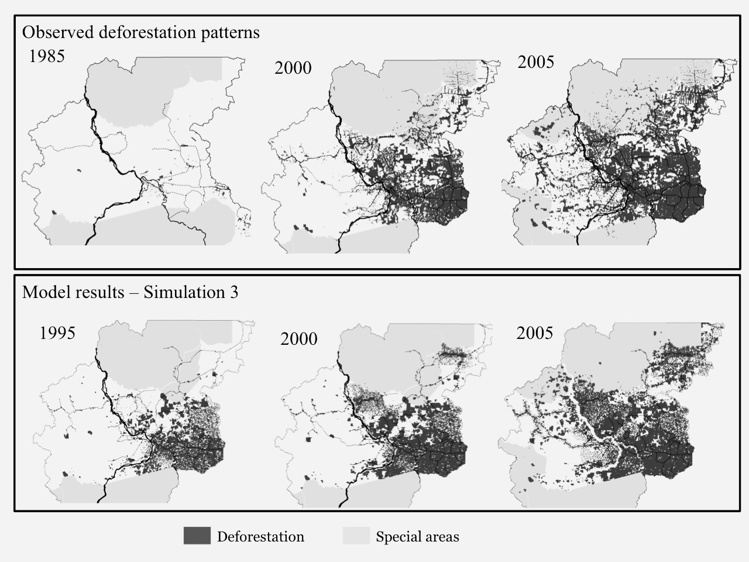
Figure 7. Comparison of observed deforestation patters (top) with results from model simulation S3 for 1985, 2000, and 2005 (bottom).

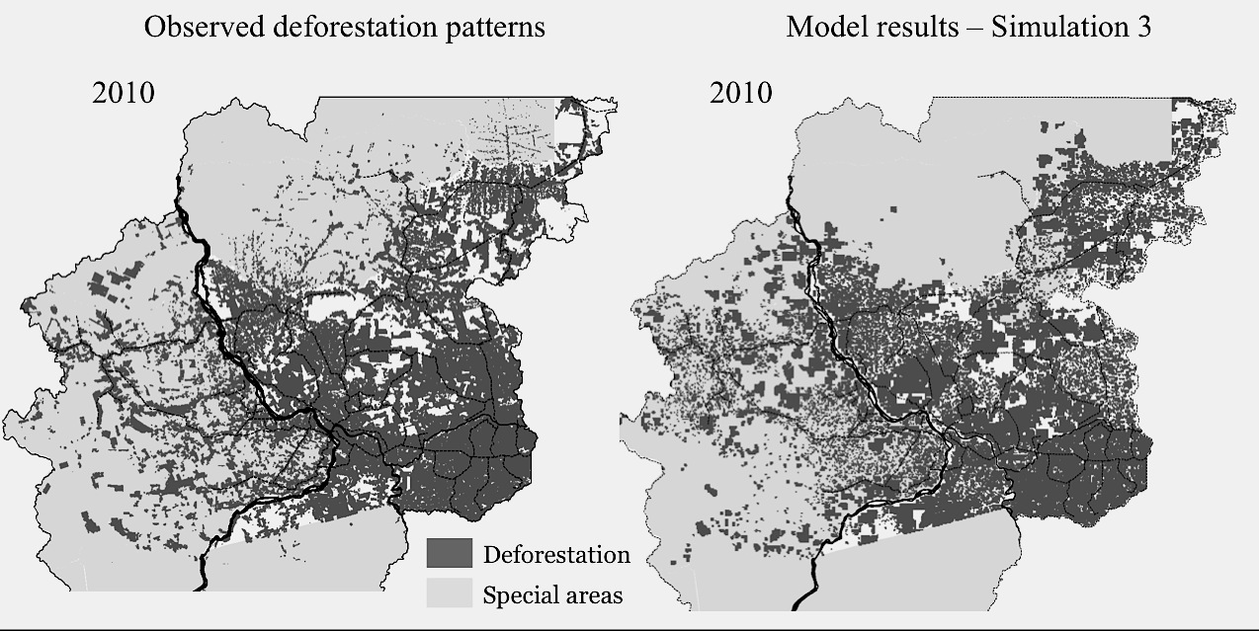
Figure 8. Comparison of observed deforestation patters (top) with results from model simulation S3 for 2010 (bottom).

To derive the spatial patterns that emerge from different institutional arrangements, the model has the agent taking two decisions. First, she selects an area for her farm, based on factors such as distance to roads and cities, soil quality and slope. Once the agent has a farm, she has to decide whether to deforest, reforest, or set pasture on it. Her decisions rest on her chosen strategy, and on how much the area is consolidated. In an area far from the city, being close to a road is better than having a flat slope. Unlike results from pattern-based models, these are not maps based on allocating a demand based on each place’s potential. The patterns emerge from the agents’ decisions, which rely on the arrangements they join.
We also ran three scenarios for the period 2012-2020, considering different arrangements, starting from same mix used in simulation S3. Scenario A adds the Green Market arrangement after 2009, applying it only to farmers who decide to be certified. Scenario B replaces, after 2013, the Deforestation control arrangement by the broader Sustainable development one. This latter arrangement balances social, economical and environmental needs. Scenario C puts economic gains before sustainability; the Economic development arrangement replaces Deforestation control after 2013. Figure 9 illustrates the major land cover differences among the scenarios. Figure 10 shows how farmer strategies change on scenarios A, B, and C. In scenario A, we have more of the same. Deforestation is controlled, but economic and social benefits are limited. In scenario B (sustainability) pasture area decreases, forest area in farms and intensive farming increase. In scenario C (economics first), the opposite happens. These simulations show that the current policies, albeit their success in reducing forest cuts, are not the best solution for the region.

Figure 9. Comparison of total pasture area (ha) and average forest area inside farms (%) on scenarios A, B, and C for 2010-2020.

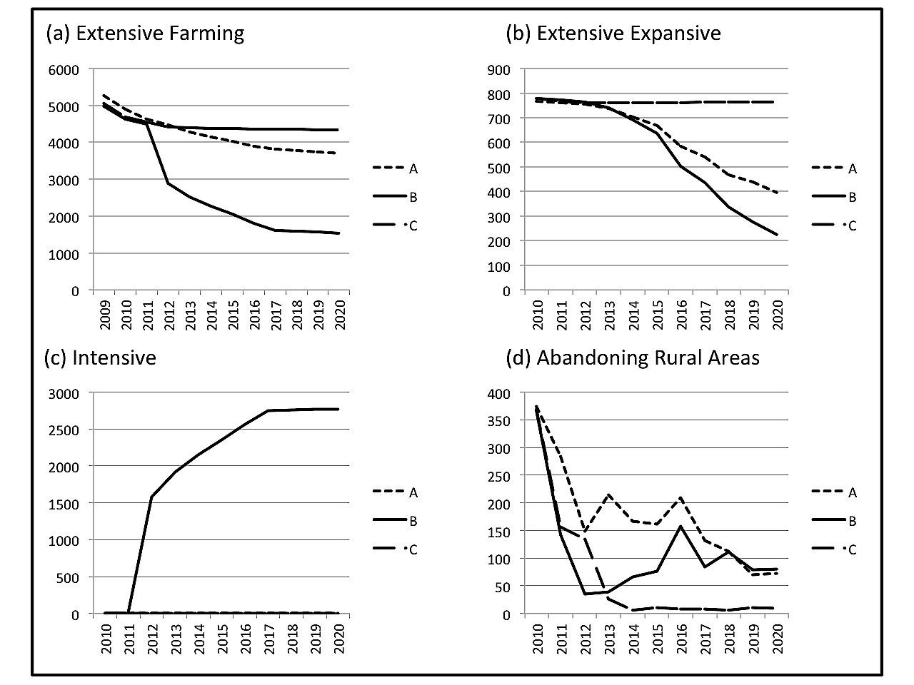
Figure 10. Variation of farmer strategies on scenarios A, B, and C for 2010-2020.
Final Remarks
This paper presents a method for building agent-based models of land change. Most agent-based models in the literature deal with individual decisions in small areas, based on field surveys. Our approach extends agent-based models to larger areas, based on collective behaviour. We assume that farmers have a limited set of strategies to manage land. Over time, a farmer may change his strategy depending on external conditions. The model includes rules and norms for controlling land use. However, agents do not follow these rules and norms all the time, and try to bend rules in their favour whenever possible. Thus, in land use studies, we need to set up conditions for conformance to rules and norms. We use the idea of institutional arrangements to define how agents follow rules and norms. The interaction between agents’ strategies, established rules and norms, and collective institutional arrangements allows for building of flexible and expressive models.
The paper also shows how to express the ideas of strategy, rules and norms, and institutional arrangements in computer simulations. The hybrid automata formalism (available in TerraME) turned out to be a good way to express decision-making when agents change their strategies over time. Results from the São Félix do Xingu model in the years 1985 to 2010 showed why institutional arrangements are needed. By making agents switch strategies when external conditions change, the model captures the landscape dynamics and replicated the deforestation fluctuations in the period. Results up to 2010 allowed us to set up simulations until 2020 with different policies and to get consistent follow-ups.
Agent-based models, when properly conceived, have good explanatory power. However, building ABMs for complex problems is hard. As Couclelis (2002) puts: “Agent-based modeling meets an intuitive desire to explicitly represent human decision making. (…) The question is whether the benefits of that approach to spatial modeling exceed the considerable costs of the added dimensions of complexity introduced into the modeling effort.” We believe that the concepts of institutional arrangements and hybrid automata can help reduce the complexity of agent-based modeling of land change.
Acknowledgments
The authors thank FAPESP for supporting project “Land use change in Amazonia: Institutional analysis and modelling at multiple temporal and spatial scales” (grant 2008/58112-0), and CNPq for funding projects “Computational modelling of complex systems” and “TerraME: Multiscale modelling of Nature-society interactions” (grants 304752/2010-0 and 560130/2010-4). We also thank the GEOMA research network, especially the help of Ima Célia Vieira, Jonas Bastos da Veiga, Rene Poccard-Chapius, and Andrea Coelho.
References
Aguiar, A.P., Câmara, G. and Escada, M.I., 2007. Spatial statistical analysis of land-use determinants in the Brazilian Amazon: exploring intra-regional heterogeneity. Ecological Modelling, 209 (1-2), 169–188.
Alves, D., 2002. Space-time Dynamics of Deforestation in Brazilian Amazônia. International Journal of Remote Sensing, 23 (14), 2903-2908.
Assis, T.O., Souza Soler, L., Aguiar, A.P. and Ometto, J., 2011. Assessing risk maps of deforestation to the Brazilian Amazon using LuccME framework. In Epiphanio, J.C. & Galvão, L. eds. XV Brazilian Symposium on Remote Sensing. Curitiba, PR, Brasil: INPE, 6042.
Becker, B.K., 2005. Geopolítica da Amazônia (Amazonian Geopolitics). Estudos Avancados (Journal of the Institute of Advanced Studies of the University of Sao Paulo), 19 (53), 71-86.
Bousquet, F. and Le Page, C., 2004. Multi-agent simulations and ecosystem management: a review. Ecological Modelling, 176 (3-4), 313-332.
Bowman, M.S., Soares-Filho, B.S., Merry, F.D., Nepstad, D.C., Rodrigues, H. and Almeida, O.T., 2012. Persistence of cattle ranching in the Brazilian Amazon: A spatial analysis of the rationale for beef production. Land Use Policy, 29 (3), 558-568.
Brown, D.G., Riolo, R., Robinson, D.T., North, M. and Rand, W., 2005. Spatial process and data models: Toward integration of agent-based models and GIS. Journal of Geographical Systems, 7, 25-47.
Caldas, M., Walker, R., Arima, E., Perz, S., Aldrich, S. and Simmons, C., 2007. Theorizing land cover and land use change: the peasant economy of Amazonian deforestation. Annals of the Association of American Geographers, 97 (1), 86-110.
Carneiro, T., 2006. Nested-CA: a foundation for multiscale modeling of land use and land change. Phd Thesis in Computer Science, avaliable at http://www.dpi.inpe.br/gilberto/teses/nested_ca.pdf. INPE.
Couclelis, H., 2002. Why I no longer work with agents. In Parker, D., Berger, T., Manson, S. & Mcconnell, S. eds. Agent-Based Models of Land-Use /Land-Cover Change. Report and Review of an International Workshop. LUCC Project, LUCC Report Series no 6. Irvine, CA.
Deadman, P., Robinson, D., Moran, E. and Brondizio, E., 2004. Colonist household decisionmaking and land-use change in the Amazon Rainforest: an agent-based simulation. Environment and Planning B-Planning & Design, 31 (5), 693-709 Available from: <Go to ISI>://000224056800004.
Dietz, T., Ostrom, E. and Stern, P.C., 2003. The struggle to govern the commons. Science, 302 (5652), 1907.
Epstein, J.M., 2006. Generative social science : studies in agent-based computational modeling Princeton: Princeton University Press.
Escada, M.I.S., Vieira, I.C.G., Amaral, S., Araújo, R., Veiga, J.B.D., Aguiar, A.P.D., Veiga, I., Oliveira, M., Pereira, J.L.G., Filho, A.C., Fearnside, P.M., Venturieri, A., Carriello, F., Thales, M., Carneiro, T.S., Monteiro, A.M.V. and Câmara, G., 2005. Padrões e Processos de Ocupação nas Novas Fronteiras da Amazônia: O Interflúvio do Xingu/Iriri (Land Use Patterns and Processes in Amazonian New Frontiers: the Xingu/Iriri Region). Estudos Avançados, 19 (54), 9-23.
Henzinger, T.A., 1996. The Theory of Hybrid Automata. Proceedings of the 11th Symposium on Logic in Computer Science (LICS'96). IEEE.
Ierusalimschy, R., Figueiredo, L.H. and Celes, W., 1996. Lua-an extensible extension language. Software: Practice & Experience, 26 (6), 635-652.
Inpe, 2010. Monitoramento da Floresta Amazônica Brasileira por Satélite (Monitoring the Brazilian Amazon Forest by Satellite). Available at http://www.obt.inpe.br/prodes. Acessed in 20 July 2011 [online]. INPE. Available from: http://www.obt.inpe.br/prodes [Accessed Access Date
Janssen, M.A. and Ostrom, E., 2006. Empirically based, agent-based models. Ecology and Society, 11 (2), 37.
Laurance, W., Ana K.M. Albernaz, A.K., Schroth, G., Fearnside, P.M., Bergen, S., Venticinque, E., Dacosta, C, 2002. Predictors of deforestation in the Brazilian Amazon. Journal of Biogeography, 29, 737-748.
Matthews, R., Gilbert, N., Roach, A., Polhill, J. and Gotts, N., 2007. Agent-based land-use models: a review of applications. Landscape Ecology, 22 (10), 1447-1459.
Mertens, B., Poccard‐Chapuis, R., Piketty, M.G., Lacques, A.E. and Venturieri, A., 2002. Crossing spatial analyses and livestock economics to understand deforestation processes in the Brazilian Amazon: The case of São Félix do Xingú in South Pará. Agricultural economics, 27 (3), 269-294.
Moreira, E., Costa, S., Aguiar, A., Câmara, G. and Carneiro, T., 2009. Dynamical coupling of multiscale land change models. Landscape Ecology, 24 (9), 1183-1194.
Pacheco, P. and Poccard-Chapuis, R., 2012. The Complex Evolution of Cattle Ranching Development Amid Market Integration and Policy Shifts in the Brazilian Amazon. Annals of the Association of American Geographers, (22 May 2012).
Parker, D., Berger, T., Manson, S. and Mcconnel, S., 2002. Agent-Based Models of Land-Use /Land-Cover Change. Report and Review of an International Workshop. Irvine, California, USA, LUCC Report Series no 6.
Pontius, R.G., Cornell, J. and Hall, C., 2001. Modeling the spatial pattern of land-use change with GEOMOD2: application and validation for Costa Rica. Agriculture, Ecosystems & Environment, 85 (1-3), 191-203.
Robinson, D., Brown, D., Parker, D., Witter, H., Gotts, N., Promborm, P., Irwin, E. and Berger, T., 2007. Comparison of empirical methods for building agent-based models in land use science. Journal of Land Use Science, 2 (1), 31-55.
Scott, W.R. and Meyer, J.W., 1994. Institutional environments and organizations: Structural complexity and individualism: Sage Publications, Inc.
Soares-Filho, B., Moutinho, P., Nepstad, D., Anderson, A., Rodrigues, H., Garcìa, R., Dietzsch, L., Merry, F., Bowman, M. and Hissa, L., 2010. Role of Brazilian Amazon protected areas in climate change mitigation. Proceedings of the National Academy of Sciences, 107 (24), 10821.
Soares-Filho, B.S., Cerqueira, G.C. and Pennachin, C.L., 2002. Dinamica: a stochastic cellular automata model designed to simulate the landscape dynamics in an Amazonian colonization frontier. Ecological Modelling, 154 (3), 217-235.
Veldkamp, A. and Fresco, L., 1996. CLUE: A Conceptual Model to Study the Conversion of Land Use and its Effects. Ecological Modeling, 85, 253-270.
Verburg, P.H., Soepboer, W., Veldkamp, A., Limpiada, R., Espaldon, V. and Mastura, S.S.A., 2002. Modeling the Spatial Dynamics of Regional Land Use: The CLUE-S Model. Environmental Management, 30 (3), 391-405.

