Mapping river sediment plume caused by small-scale gold mining within Indigenous and Protected Areas of the Brazilian Amazon using multi-satellite images.

Felipe Lobo*, Vitor Vasconcelos#, Lenio Galvão*, Evlyn Novo*, Maycira Costa&, Kevin Telmer%
*INPE
#ICMBio
&Uvic
% Artisanal Gold Mining Council
Abstract (up to 250 words)
Xooxoxoxoxoxoxox

- Introduction
In the Amazon, substantial Artisanal small-scale gold mining (ASGM) activities started in the 1950s at a few sites, called ‘garimpos. Currently, hundreds of thousands of people are directly involved in ASGM in the Amazon Basin because of the relatively high gold price (US$1100/oz) (Sousa and Veiga 2009, Silva 2012, Fernandes et al. 2014) (Veiga 1997, Telmer and Stapper 2007, Sousa and Veiga 2009). In Brazil only, ASGM gold production is responsible for 30 tonnes per year, of which approximately 26% is produced in the Tapajós River Basin in the Amazon by approximately 50,000 miners (or ‘garimpeiros’) distributed in more than 300 mining sites (Araújo Neto 2009, CPRM 2009, Silva 2012, Fernandes et al. 2014). Add about alta floresta, Yanomami..acho que o Aman”a entra na conta do Tapajós..
Despite its contribution to the local economy, ASGM causes several environmental impacts, such as mercury contamination, water siltation, and landscape degradation, and social conflicts (Rodrigues et al. 1994, Sousa and Veiga 2009). ASGM causes social conflicts where they take place. First because it is an informal and, mostly, illegal activity in Brazil. Second because in some areas they invade protected and/or indigenous lands which trigger several conflicts between miners (garimpeiros) and local indigenous. A dramatic example is the case of Yanomami Land where ASGM has taken place since 1970s when garimpeiros invaded their land and among many disturbances, brought numerous diseases that indigenous had not been exposed too, such as cold and etc. Add info about the negative consequences of garimpos in Yanomami..
In terms of environmental impacts, mercury contamination which is widely reported (examples). Moreover, ASGM takes place mostly over alluvial deposits (river network) using either dredges and water-jet systems that cause dislodging of bottom or top-soil, respectively (Rodrigues et al. 1994, Fernandes et al. 2014). This ASGM practice results in high water siltation due to the discharge of sediment from the margins of the rivers. The discharge of sediment into the water has severe impacts on the water quality, such as decreasing light availability for primary production (Roland and Esteves 1998), and changing benthic (Tudesque et al. 2012) and fish communities (Mol and Ouboter 2004).
The environmental impacts caused by ASGM, such as quantification of water siltation using satellite images is rarely performed either because of lack of water quality data (for example, TSS and Chl-a); or because of limitation of satellite images specifications such spatial resolution (small rivers require high spatial resolution, ~5m) (Telmer et al. 2006, Sousa and Veiga 2009, Telmer and Veiga 2009). In the case of the Tapajós (PA), Uraricoera (RR) and Teles Pires river (MT), the main channel and some tributaries are wide enough to be detected by medium-resolution satellite images such as Landsat (30m) and IRS-LISS3 (24m). In the case of Amanã river, which is a narrow river only detectable by high-resolution images such as Rapideye (5m). A dataset of in situ data such as radiometry and TSS data are also available for Tapajós river as a result of two field campaigns taken place in 2011 and 2012.
Therefore, the main objective of this paper is to map the sediment plume caused by artisanal gold mining in the Brazilian Amazon using satellite imagery in 2012. More specifically, the objective is to apply the methodology used by Lobo et al (2015) to retrieve TSS from satellite images using an empirical regression. This model will be applied into different study areas that present similar characteristics of water biogeochemistry and are subject to different gold mining exploitation intensities. The socio-economic aspects such as mining distribution, history of ASGM in each region will be presented and discussed.
- Material and Methods
  - Study Areas
The study areas were selected according to a few criteria: First, rivers that drain areas of rocky shield of central Brazil or Guiana shields, presenting a natural aspect of clear water. Second, areas where ASGM is taking place (active). Third, basin areas that can be detected by medium spatial resolution images or high resolution. Considering these criteria, four areas were defined: A) the Tapajós River; B) the Amanã River; C) the Teles Pires River; and D) the Uraricoera river.
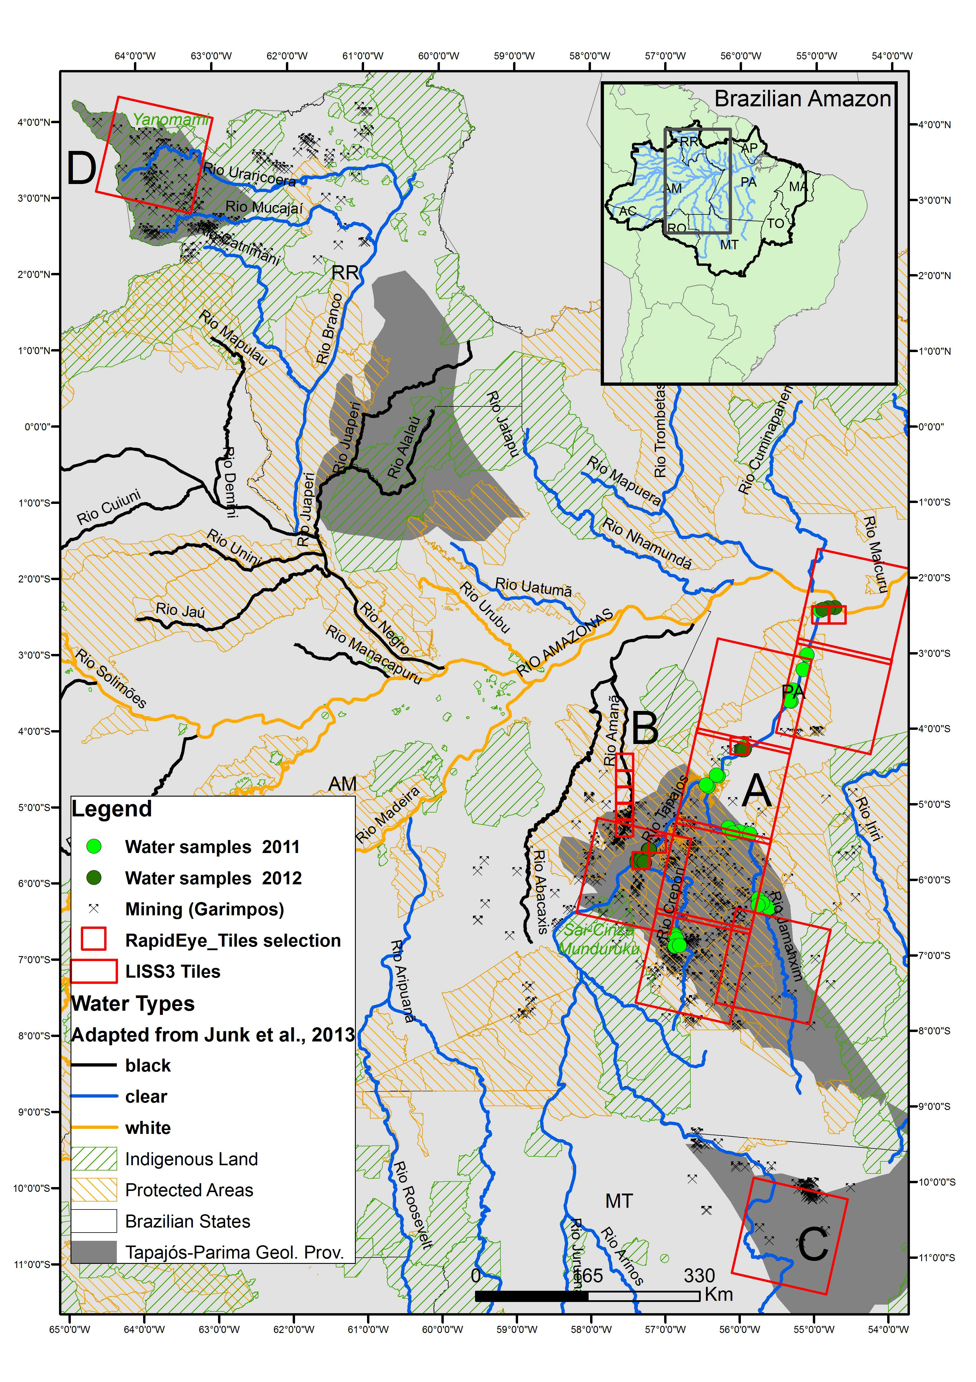
Figure 1: Study areas in the Brazilian Amazon. A) Tapajós River Basin; b) Amanã River; c) Teles Pires river, Peixoto Azevedo Region (MT); and Uraricoera river, Yanomami Land (RR).

- The Tapajós River
The lower section of the Tapajós River Basin located in the state of Pará (Brazil) covers about 130,370 km2 (Figure 2.1) and drains mostly lixiviated Pre-Cambrian rocks, which results in waters that are transparent/greenish in colour with low amounts of suspended solids, and are generally called ‘clearwaters’ by the research community (Sioli, 1984; Junk, 1997). The river basin can be generally separated into two geomorphological sections: the upstream riverine section (lotic system), from the headwaters down to the Aveiro City region; and the downstream section (semi-lentic system), from Aveiro City to the mouth of the river where it merges with the Amazon at Santarém City (Figure 2.1).
Currently, more than 300 small-scale mines with participation of more than 50,000 miners produce gold within three main sub-basins: the Novo, the Crepori, and the Tocantinzinho (abbreviated to Tocantins) (see Figure 2.1for locations). Recent investments by gold mining companies and local miners have introduced more than 50 pitloaders in the region, increasing the capacity for mineral processing compared to water-jet systems, and potentially increasing the discharge of mining tailings into the rivers as well (Silva, 2012; ICMBIO, 2010).
The sediment plume generated during small-scale mining operations is composed mostly of fine inorganic particles (TSS up to 300 mg.L-1) that can carry significant 17 amounts of mercury and are mostly discharged into the rivers. The grain size of tailings varies from coarse (2 mm) to as fine as clay (<0.002 mm), indicating that this fine and light sediment can be carried for long distances in the rivers (Telmer et al., 2006).
Two field campaigns were performed at the Tapajós River to collect radiometric and water quality data, as a total of 39 sample points, in order to establish an empirical model to retrieve TSS values from satellite images. Satellite images, landsat, liss, and rapideye…
- The Amanã River
The Amanã river is located between the state of Pará and Amazonas, and most of the ASGM is related to Tapajós Gold Domain (Santos 2001), also in terms of transport and commercialization of the gold exploited. Although the headwaters are close to Tapajós river, this river is classified as black water type with high dissolved organic matter content. The high absorption characteristics of CDOM results in water with dark aspect. Similarly to clear waters, the input of suspended sediment into the water increased the reflectance signal which help detecting its distribution along the river. The inclusion of this area holds on the need for information about ASGM impacts on aquatic systems by the Environmental Protection Agency (ICMBio) for a better management of protected areas in the Amazon. Because Amanã river is narrower than Tapajós, the water mass is only detectable with high resolution images. For that reason, 5 tiles of the RapidEye satellite were used in this area. The ASGM in this area…..
- Teles Pires River
The upstream Tapajós is formed by the confluence of two rivers Juruena and Teles Pires. The area drained by the Teles Pires river present some ASGM as shown in Figure 1, for that reason it was selected for this study. The ASGM in this area is concentrated at Peixoto Azevedo city where more than 55 garimpos has been identified by CPRM….Is an area remarked by high deforestation rate, mostly converted into pasture and agriculture fields. MT is one of the most productive Brazilian states when it comes to soybean and ::..
- Uraricoera river (Yanomami Indigenous Land)
Description of the region. TI Yanomami…Uraricoera drains Guiana Shields which result in clear water type. 22 garimpos have been identified by CPRM in TI Yanomami, XX of those within de IRS/LISS3 tile (222/345) (Study area D).
Santos et al (2001) In the Parima (RR) gold domain, the mining activity lasted only 5 years (1988-1993), but, during this time, 168 alluvial and colluvial mines were active. Some of the mines are located inside the Yanomami Indigenous Land so the Brazilian government shut down these in 1993…
Table 1: Dataset of images and in situ data per each study area. In situ data available only for the Tapajós River.
Study area | water level (season) | satellite/sensor | number of scenes | path/row | Date of acquisition | atm correction | in situ data (number of samples)
A- Tapajós | High | Landsat 5/ TM | 7 | 227-229/62-65 | Apr-11 | 6S | 23
 | Low | IRS/LISS3 | 8 | 310-314/66-69 | Sep-12 | Flaash | 16
 |  | RapidEye | 5 | 2136413 2136514 2137119 2137924 2137925 | Jul-Ago-2012 | Flaash
B - Amanã | Low | RapidEye | 5 | 2136612-2137012 | 06-Aug-12 | Flaash | -
C - Teles Pires | Low | IRS/LISS3 | 1 | 320/84 | 06-Aug-12 | Flaash | -
D - Uraricoera | Low* | IRS/LISS3 | 1 | 309/72 | 03-Nov-12 | Flaash | -
* Low water level season in the Uraricoera river (Northern Amazon) is from oct to jan, as opposed to jun-sep in the Amazonian southern rivers.

  - Field campaigns: radiometric and TSS data
Two field campaigns were conducted in the Tapajós River Basin (site A) to measure radiometric quantities and TSS concentrations: March/April 2011, during high water level (23 sample points); and September 2012, during low water level (16 sample points) (Figure 2a). The field campaigns were defined based on periods when the water system is less dynamic and changes in water quality are slower compared to receding or flooding periods. This choice would contribute to matching in situ data with concurrent satellite images. The sample point locations were defined in order to cover the spatial distribution on the main Tapajós River tributaries before and after their discharge, and along the Tapajós River to cover its lengthwise variation. For each sample point, two water samples were taken at a depth of 0.3 m to determine TSS concentrations according to the gravimetric method (APHA, 2005). For each water sample taken, triplicates of pre-weighted (0.7 μm) filters were used to determine TSS average and standard deviations in the laboratory.
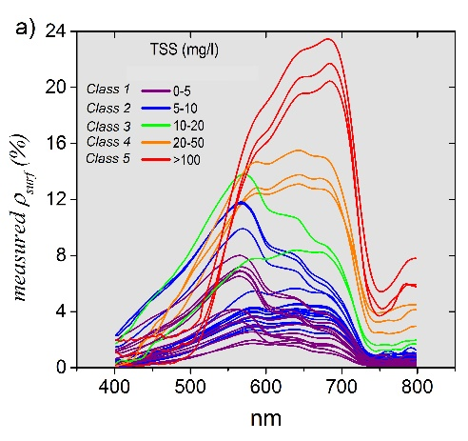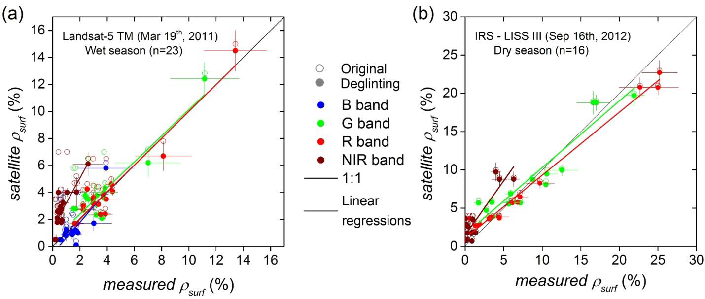
Figure 2: Sample sites visited in april 2011 and sept 2012 for radiometric measurements and Total Suspended Solids (TSS) estimations. (a) The radiometric measurements (surface reflectance at red) at red region, for example, varied from 3% to 23% in waters with 2.0 to 113 mg/L of TSS, respectively. (b) Figure XX: Scatter plots between measured 𝝆𝒔𝒖𝒓𝒇 and corrected satellite at VNIR channels for (a) Landsat-5 M, (b) IRS – LISS III. 𝝆𝒔𝒖𝒓𝒇 before (empty circles) and after (filled circles) glint removing is also shown. Linear regression and standard deviation (error bars) are plotted only for deglinted data.
  - Satellite images and atmospheric correction
Images of different satellites were used in this research to retrieve TSS. Initially, a dataset of 12 satellite images taken in April 2011 (Landsat TM5) and September 2012 (IRS/LISS3) were calibrated with measured radiometric data. First, the images were downloaded at www.dgi.inpe.br and atmospherically corrected using the physical model (6S for Landsat and FLAASH for Liss3). Second, the atmospheric parameters such as Aerosol thickness, ozone and water vapor were optimized in order to match the radiometric data measured in situ during the same period (Figure 2b and c).
Once the atmospheric correction was validated with in situ data, the forest spectra extracted from these images were used as a reference to optimize the FLAASH atmospheric inputs (AOT, water vapour) for correction of IRS/LISS3 and RapidEye images of the study areas B to D (see Lobo et al., 2015 for image intercalibration method).
  - Estimating TSS from corrected images in 2012
To establish an empirical relationship between measured TSS and IRS/LISS3 data, the TSS concentrations measured at 39 sample points were correlated with reflectance derived from satellite sensors (Landsat-5 TM data for high water level and LISS-III data for low water level season). Measured TSS concentrations were higher in those rivers with intense gold mining activity, such as the Crepori River. During high water level, TSS values of 35.3 mg/l were observed in this river, whereas in the low water period, concentrations up to 115.2 mg/l were measured (Figure 3). The TSS or intervals were defined arbitrarly considering the range of available data (0-5, 5-10, 10-20, 20-50, 50-120, >120 mg/L).
Considering the different spectral resolution of LISS and Rapideye sensors, and that we observed a sliglhty difference between R% (red) LISS and Rapideye of 16 sample sites taken in September 2012 in the Tapajós area (Crepori mouth) (slope is 1.07) we chose to apply and new empirical regression using measured reflectance resampled to Rapideye spectral resolution. Overall, for IRS/LISS3 images we applied the regression at Figure 3a, and for Rapideye Images we applied the regression in Figure 3d.
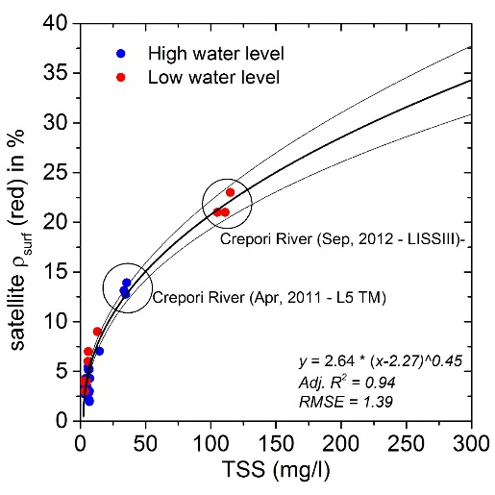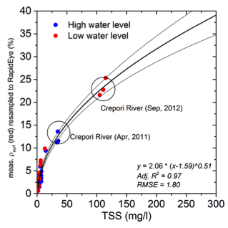

Figure 3 : The empirical regression between satellite R% at red (LISS3 sept/2012) and TSS values (n=39) shows high significance of TSS estimation from satellite the range of 3 to 25% (R2=0.94, RMSE=1.39). n = 16 for Rapideye vs Liss.

The TSS estimation from the Rapideye and LISS images for all study areas (A to D) is discussed considering socio-economic aspects such as ASGM (garimpos) distribution, history of economical activities in each area, gold mining techniques, territorial conflicts in regards to Indigenous and Protected areas.
- Results
The quantification of TSS using satellite images will be presented separately for each study area and will focus on information of 2012. Firstly, a comparison between TSS estimated with LISS and Rapideye in Tapajós River will be done. Secondly, TSS estimation of study areas B, C and D will be presented along with relevant information to characterize ASGM activities and their discharge of sediment into the water.
- The Tapajós River Basin

The TSS distribuition over the Tapajós River and the main tributaries (Crepori and Jamanxim rivers) is extensively presented in Lobo et al (2015) in a temporal and spatial analysis. Overall Lobo et al (2015) describes that TSS exhibited higher concentrations at low water level than at high water level periods. In the low water level season of 2012, for example, TSS values of about 115.0 mg/l were estimated for the Crepori River. After the Crepori discharge into the Tapajós River, the high TSS is mixed with the relatively low TSS waters of the Tapajós, and at approximately 260 km downstream, the TSS concentration decreased to about 7.5 mg/l at Itaituba City and down to 4.0 mg/l at the Santarém area. Similar values were observed for the high water season, but at lower TSS concentrations.
In the present study, we will focus on the comparison of TSS estimated using LISS to Rapideye. For example, estimation of LISS (date) showed that TSS is up to 112.5 +- 15.0 mg/l on the Crepori mouth (Figure 4), the sediment plume

